e Official Publication of ALOA—An International Association of Security Professionals



;cember 2001

[www.aloa.org](http://www.aloa.org)

:

'si

n

■3CS

>cs

CM  
"\

-• t-H

SCO  
iOJ

T~I

3

e —i  
c TZ

c

e **Cl.**

: non  
: <r r^-

oo<r

f^-CD

x <r

Xh

UiXi<L

Lu

**CCOh-**PCl LJL <C

o

r^.

o

0

1

Psl

-o

n

o



Tools!

**Stuff your Stockings  
with the Latest from  
Lockmasters,  
Gary, StrongArm,  
Keedex,  
Hawkeye,  
Timemasters,**

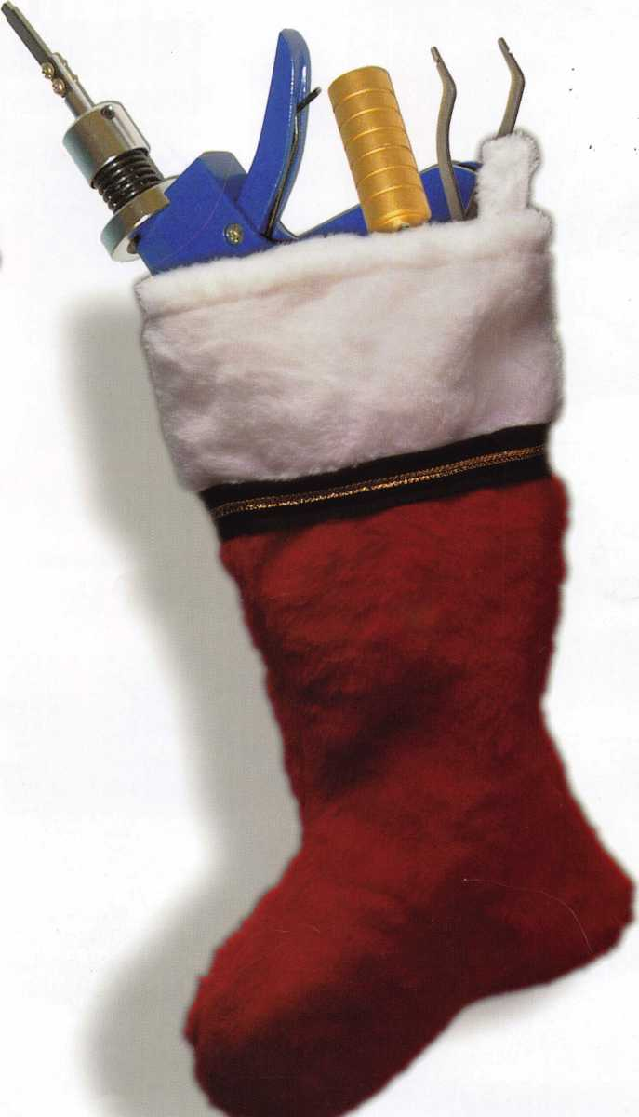

**and More!**

' - ■ : - •

**Pu*0** , c,n **'e20°\ps**

**" Jump ahead of the competition at  
uiarp speed and see your profits soar.**

|  |  |  |
| --- | --- | --- |
|  | | V >' % ' ' ' : |
|  |  |  |

**Hickok’s New Generation STAR transports you with the factory tool for programming keys to  
Ford-Lincoln-Mercury and Mazda vehicles with passive anti theft systems (PATS).**

**Program vehicle keys through Model Year 2001 with Hickok’s NGS Model 800-8LA-$1995 ^ Update your existing software-the 2001 Complete New Model Ford Software Update Model 80LA-$895**

**800/342-5080**

**HICKOK**

**INCORPORATED**

**upuHu.hickok-inc.ct**

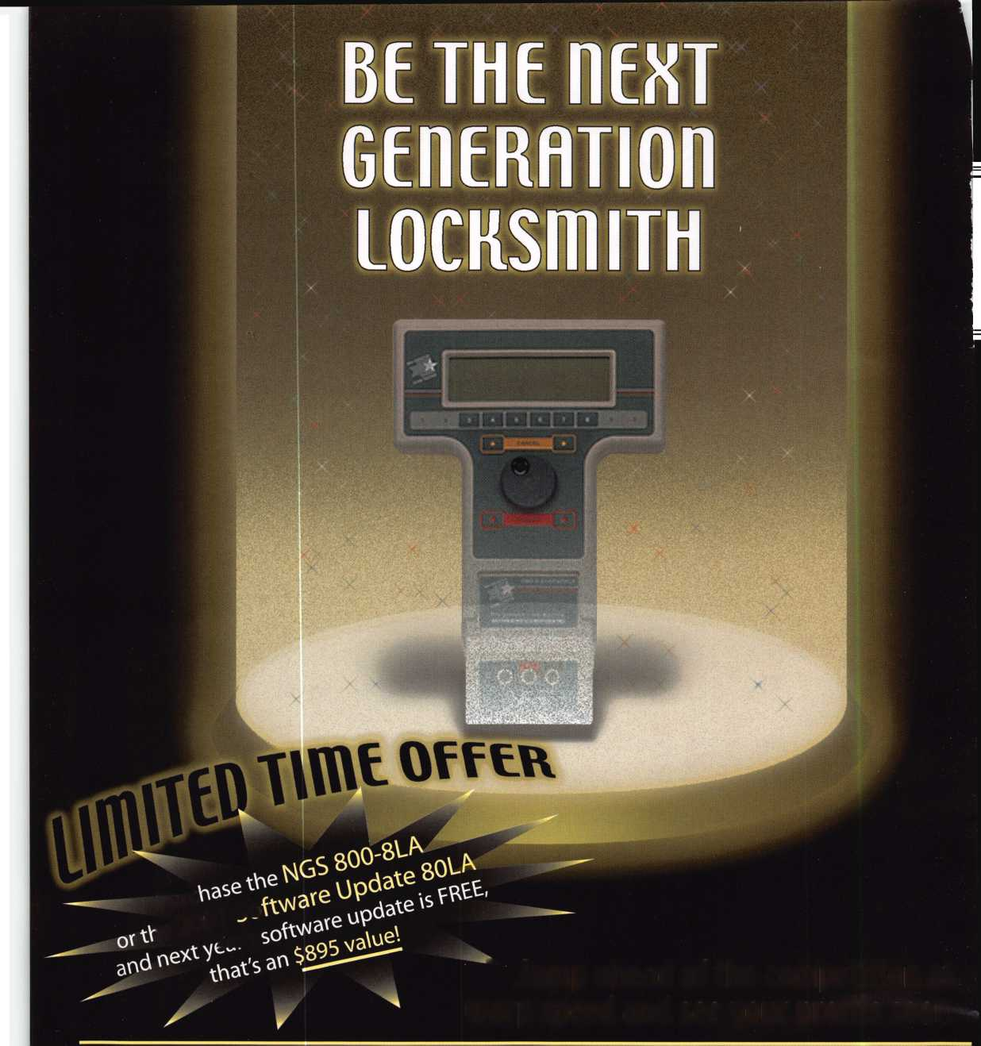

in Keynotes)

**For Chapters and Affiliates Who Recruit!**

If your chapter gets 15 new members: ALOA will send instructors out to your site for two free days of ACE classes FREE OF CHARGE! Plus, the chap­ter or affiliate that recruits the most new members gets three free convention packages for our blowout show in sparkling Las Vegas in July of 2003!

**HUIA locksmiths Secure America**

Attention Current Members! As the best security pros in :he world, you play a vital role in making ALOA what it s. You make our industry hum, and we're going to orove it this year by offering you more benefits than ever. For the entire calendar year of 2002, those who recruit new members will receive special gifts from ALOA. We're asking you to prove you're a pro by sup­porting the only professional organization that exists to help educate, protect and promote security profession­als in America and beyond. Here are some of the details of our campaign:

**For New Members!**

All newly recruited members receive a useful ALOA 11-piece pick set from LAB, plus our stirring "ALOA Locksmiths Secure America" decal for your shop or van.

**For Current Members Who Recruit!**

1 new member: The useful ALOA 11-piece pick set from LAB.

5 new members: A handsome ALOA Polo Shirt (w/ stitched logo)

10 new members: LAB's great Schlage/Kwikset Combination pin kit -- plus membership in the ALOA President's Club, with your choice of a dazzling ALOA ring or a classic ALOA blazer (plus a periodic listing

Don't pass up this%farif tic chance for these great free giveaways, an . expanded group of peers with whom to learn and grow, and the same fantastic education, protection and promotion ALOA has been providing for our great profession for almost 50 years! Call us today at 800/532-ALOA (2562) for more informa­tion, or visit us on the

Receive

**and**

web at [www.aloa.org](http://www.aloa.org).

C

°oi **Gift'-**

**ALOA Membership. Prove You're a Pro.**

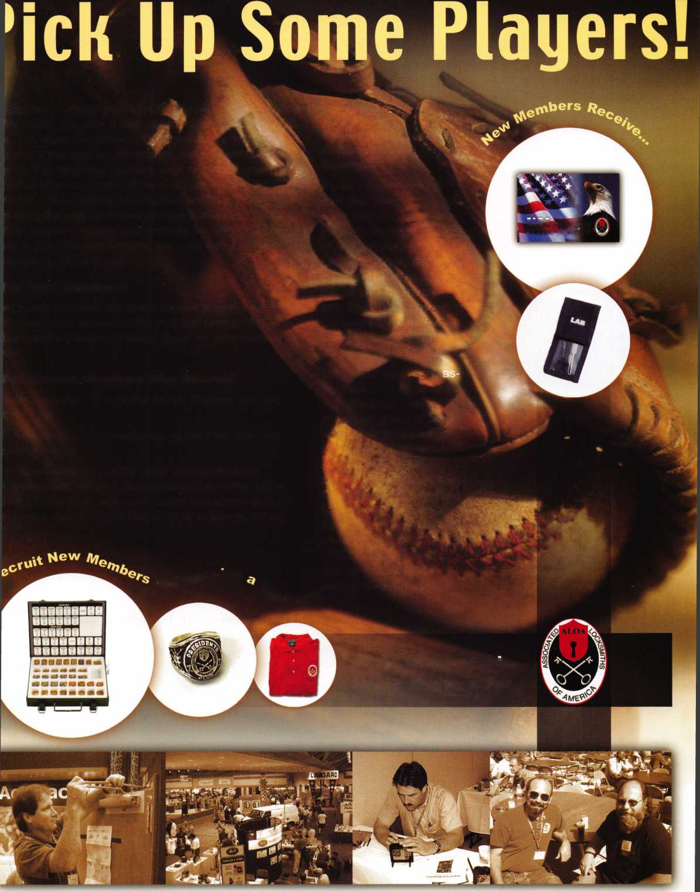

features

12

Opinion: The Big Burglar Alarm

Industry Bucket By James J. Wh ite

With the alarm guys taking aim on just about everything we hold sacred, there's never been a better time to team up with your lock­smith peers and focus on emerging harmful legislation.

14-24 Cover: Double Feature Tools Issue

|  |  |
| --- | --- |
| I departments | | |
| President's Journey | 4 |
| Upcoming Events | 6 |
| Applicants | 8 |
| Core | 10 |
| Legislative Update | 38 |
| Classifieds | 40 |
| Associate Member Listing | 42 |
| Back Page | 44 |
| L | J |

14

Stocking Stuffers from Lockmasters By Tom Seroogy

The holidays are the perfect time to stock up on the latest tools - and Lockmasters is never short in that department. Make your list and check it twice.

**20**

Safes: Santa's Big Helpers. ByGreg Perry, cml,cps

Not a creature was stirring, except for a stubborn Gary Money Chest. It got every tool in the bag.

26

Basic Locksmithing: Snowy Lockout Horror in Middle Minnesota By Cory Schmidt

It all began on a cold December day. By the end of it, our hero was wondering why locksmiths are so dutiful when it comes to car-burying snow-drifts.

28

Access Control: HID's Electric Expansion - eProx Lock Program Grows in 3s

Three new HID partners - Fort Lock, IR/Schlage and Recognition Source - weigh in on the features of this new electronic wonder.

32

Institutional Locksmithing: Big 10 Style By David Hasty, crl The unionized lock shop at the University of Illinois at Urbana Champaign covers lots of ground. Join the Fightin' lllini as they sort through a host of building security issues.

Visit

our we

b s i t e at

WWW

. a I o a . o

r 9

Keynotes

**executive**



Editor

Jim DeSimone.

Additional contact information for the ALOA Board and most Keynotes authors is available through "Locksmith Search'" on the ALOA Web site- [www.aloa.org](http://www.aloa.org) or by contacting the ALOA office at 3003 Live Oak Street; Dallas, TX 75204; (800)532-2562; FAX (214)827-1810; e-mail [aloa@aloa.org](mailto:aloa@aloa.org).

Operations/Membership Manager

[editor@aloa.org](mailto:editor@aloa.org) Mary May [mary@aloa.org](mailto:mary@aloa.org)

Technical Editor

David Lowell, CML, CMST [david@aloa.org](mailto:david@aloa.org)

Director of Information Technology

Randy McChristian [randy@aloa.org](mailto:randy@aloa.org)

Editorial Advisor

John D. Cannon, CML [jdcannon@worldnet.att.net](mailto:jdcannon@worldnet.att.net)

Art Director

Betty Henderson [betty@aloa.org](mailto:betty@aloa.org)

Government Affairs Manager/

Chapters & Regional Associations Liaison

Tim McMullen [tim@aloa.org](mailto:tim@aloa.org)

Comptroller Kathy J. Romo

Advertising Sales

Susan Haverkamp e-mail: [adsales@aloa.org](mailto:adsales@aloa.org)

121 Davis Street Nacogdoches, Texas 75961 Phone: (936) 569-7172 VoiceMail: (208) 248-8893

Executive Director

Charles W. Gibson, Jr., CAE [charlie@aloa.org](mailto:charlie@aloa.org)

Convention & Meetings Manager

Kelly Carr, CMP [kelly@aloa.org](mailto:kelly@aloa.org)

PRP/Education Manager

David Lowell, CML, CMST [david@aloa.org](mailto:david@aloa.org)

Network Specialist Greg Jackson

Membership Coordinator Shelly Jett

Convention & Meetings Assistant

Karen Lyons [karen@aloa.org](mailto:karen@aloa.org)

PRP/Education Coordinator Ashley Manson

Accounting Coordinator Kathy Green

Mail Room Coordinator Humberto Cerda

Receptionist Alin Valdez

Contributors

Jerome Andrews, CML Paul Chandler, CRL Claire Cohen, CML Brian Costley, CML, CMST Ray D'Adamo, CML

Sal Dulcamaro, CML Billy Edwards, CML Dan Graffeo, CRL,CMST AJ. Hoffman, CML Jeff Nunberg, CML, CMST

Mike Oehlert, CPL, CPS Randy Simpson, CML Robert Stafford, CML Dave Thielen, CML Greg Perry, CML,CPS

Tom Seroogy Charles Stephenson, CPS Dennis Watanabe, CML, CMST

Mission Statement: The Associated Locksmiths of America, Inc. is dedicated to enhancing the professionalism, education and ethics among lock­smiths and those in related sectors of the physical security industry. With approximately 10,000 members in the United States, Canada and the free- world, ALOA is poised to help members obtain the knowledge, the strength, and the confidence to perform their role in the physical security field with pride and dignity. But it is only through active involvement and participation that ALOA can fully achieve its potential—and can help members to achieve theirs.

Policies: Keynotes® is the official publication of the Associated Locksmiths of America, Inc. (ALOA). Keynotes® acts as a moderator without approving, disapproving, or guaranteeing the validity or accuracy of any data, claim, or opinion appearing under a byline or obtained or quoted from an acknowl­edged source. The opinions expressed by the authors do not necessarily reflect the official views of ALOA. Also, appearance of advertisements and new products or service information does not constitute an endorsement of products or services featured by the Association. The Association does not accept responsibility for the inaccuracy of any data, claim, or opinion appearing in this publication, due to typographical errors on the part of the authors, Association staff or its agents.

Editor's Note: This publication is designed to provide accurate and authoritative information in regard to the subject matter covered. It is provided and disseminated with the understanding that the publisher is not engaged in rendering legal or other professional services. If legal advice and other expert assistance is required, the services of a competent professional should be sought.

Authors' Payment: Payment for eligible submissions to Keynotes will be based on the following criteria: topic, time spent and past contributions. Authors who regularly submit to Keynotes® are generally paid a higher rate. The latter is especially true of authors who write to fit specific editorial needs and submit said copy by Keynotes® deadlines. As a general guideline: Average payment for a 750 word, business or light' technical article would be $200. Payment for a 1500 word article involving significantly higher time and research efforts would be $400.

Payment will not be offered for articles submitted by ALOA employees or members of the ALOA Board of Directors (unless material is of a technical nature), nor for articles submitted by a company that promote that company's products or services. ALOA reserves the right not to pay for articles sub­mitted by an individual(s) that promote a particular company's products or services.

Disclaimer: The Associated Locksmiths of America, Inc., (ALOA), reserves the right to refuse any article for any reason. Additionally, ALOA reserves the right to edit, amend or modify any article submitted for publication in order to preserve technical accuracy, clarity, fairness or grammatical cor­rectness. ALOA will make the best efforts to notify the author of any changes. The extent of ALOA's liability for any article or information contained therein will be a notice of correction or retraction in the next possible issue.

Keynotes® (ISSN 0277 0792) is published monthly except for the combined June/July issue by The Associated Locksmiths of America, Inc., 3003 Live Oak St., Dallas, TX 75204-6186. Telephone: (214) 827-1701; FAX (214) 827-1810; e-mail [aloa@aloa.org](mailto:aloa@aloa.org). Subscription rates for members—$15.00 per year. Second class postage paid at Dallas, Texas. POSTMASTER: Send address changes to: Keynotes, 3003 Live Oak St., Dallas, TX 75204-6186. © Copyright 1999, All rights reserved. No part of the contents may be reproduced or reprinted in any form without prior written permission of the pub­lisher.

President

Randy Simpson, CML  
(713)780-7026  
[presidant@aloa.org](mailto:presidant@aloa.org)

Secretary

John D. Cannon, CML  
(703) 960-6413  
[jdcannon@worldnet.att.net](mailto:jdcannon@worldnet.att.net)

Directors, Northeast

John C. Magee, III  
(856) 845-3434

Peter Saraitian, CRL  
(201)947-6291  
[psarailian@yahoo.com](mailto:psarailian@yahoo.com)

William L. Young, CML  
(610)647-5042

Directors, Southeast

Vincent Formon, CML, CPS  
(901)324-2910

Donald E. Rufe, CML  
(601)324-2658  
rulecml@ebicom. net

Directors, North Central

Mark E. Blum, CML, CPS  
(517)482-5809  
[mbium@arq.net](mailto:mbium@arq.net)

John Soderland, CML, CMST  
(414) 327-5625  
ncd i rector@a loa. org

Director, South Central

Randy L. Simpson, CML

1. 780-7026

Directors, Southwest

Gordon R. Racine, CML

(719) 384-4707

swdirecfor@aloa .org

Julie McCluney, CRL

1. 636-5652 swdi recfor@aloa ,org

Director, Northwest

Scott L. Henke, CRL, CPS  
(907) 248-3785  
[action@alaska.net](mailto:action@alaska.net)

Director, Associate Members

David F. Matthies  
(727) 541-5536  
[dmatthies@southernlock.com](mailto:dmatthies@southernlock.com)

Trustees

John j. Greenan, CML, CPS  
(773) 486.2030

Dallas Brooks  
(334) 826-8990

David M. Lowell, CML, CMST  
(800)532-2562

Edwin Toepfer, RL

(416) 225-5589

Past Presidents

1999-2001 John Greenan, CML, CPS  
1997-1999 Dallas C. Brooks  
1995-1997 David Lowell, CML, CMST  
1993-1995 Breck Camp, CML  
1991-1993 Henry Printz, CML  
1989-1991 Evelyn Wersonick, CML, CPS  
1987-1989 Leonard Passareilo, CPL  
1985-1987 Joe Jackman, CML  
1983-1985 Stanley Haney, CPL  
1981-1983 Louis LaGreco, CPL  
1979-1981 John Kerr, RL  
1977-1979 Clifford Cox, CML  
.1974-1977 Charles Hetherington  
1972-1974 Gene Laughridge  
1970-1972 William Dutcher, RL  
1968-1970 Constant Maffey, RL  
1966-1968 Harold Edeisfein, Rl  
1964-1966 William Meacham  
1962-1964 Robert Rockiiffe, CPI  
I960-1962 Edwin Toepfer. RL  
1956-1960 Ernest johannesen

Keynotes

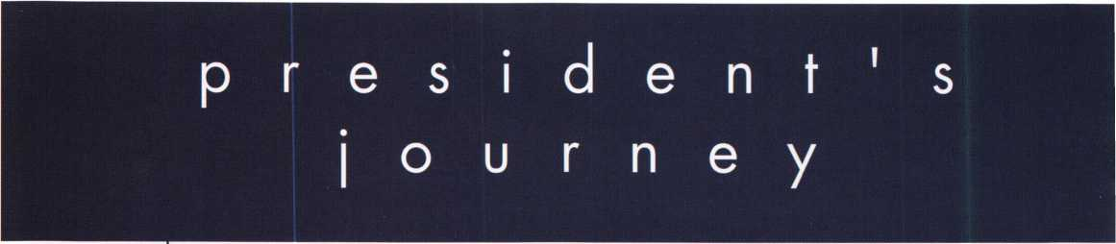

Hello Members,

Why did you join the Associated Locksmiths of America? Was it for the educational pro­grams, PRP Registration, great conventions, Technical Magazines or for the pride of recog­nition? Maybe it was for that word "association/' just to be around a group of industry leaders. I think it was for all of these reasons. The cream always rises to the top. As mem­bers, each of you represent the best Security Professionals in the world.

This month, all of us at ALOA are calling on you to Prove you are a Pro. You are the one who makes our association strong. We have special gifts for everyone. Current members who recruit one new member get an ALOA 1 1-piece pick set from LAB. Everyone who renews for 2002 gets an "ALOA Locksmiths secure America" decal for your shop or van. This part is just for you, the benefits solely your own.

Now do something for yourself and ALOA. Recruit 5 new members to join and we will give you a great ALOA Polo shirt (w/stitched logo). Get 10 new members and receive a LAB Schlage/Kwikset Combination pin set. Wow — you will still get more! These same 10 recruits certify your entry into the Presidents Club. Take your pick of an ALOA ring or an ALOA blazer. Plus the recognition in Keynotes magazine's "President's Club" listing.

Reviewing the current members of the "President's Club," I have about 100 members who have contributed an average of 20 members each. WOW! That adds up to 2,000 mem­bers. I will be sending each of you a letter of thanks for your contribution to our associa­tion. I hope many more of you will pick up my personal challenge to recruit 10 new mem­bers for your entry into this elite club of the "Best of the Best."

Randy Simpson, CML

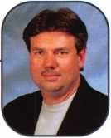

Keynotes



*bfTJil*

***Visit our Website on****[www.stamcctv.com](http://www.stamcctv.com)*

**THE COMPLETE  
CCTV PROGRAM ON CD-ROM  
FOR STAFF TRAINING AND**

**PRODUCTIVITY ENHANCEMENT**

STAM Insight has been

developed to enhance CCTV  
skills and productivity with

many different uses.

Productivity

w System Drawing 00 Estimation # CCTV Training **00** CCTV Reference **00** Sales/Demo 10 System Design 10 Staff Evaluation

CCTV Content

CCTV Calculators

*mmm*

Demonstration Tool

Estimation

Drawing

Internet Enabled

|  |  |  |
| --- | --- | --- |
|  |  |  |
| INFOMATE | WORKMATE | ULTIMATE |

**Sold in Over 50 Countries**

s&&/

Distributed by:



3003 Live Oak Street  
Dallas,Texas 75204

COPYRIGHT © 1996 Security Training and Marketing Pty Ltd.  
All rights reserved ACN 057 006 541

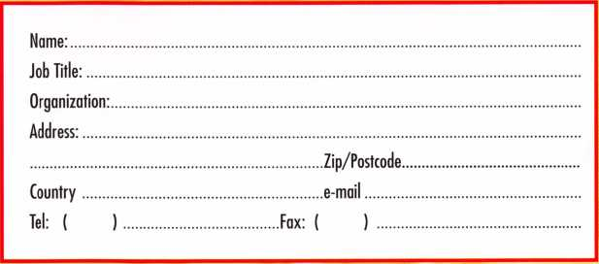

iohHh

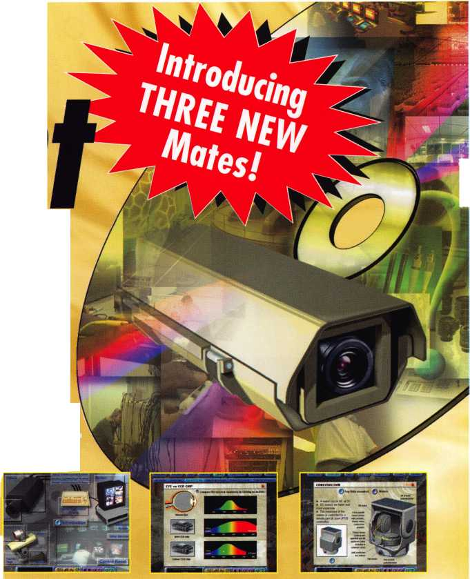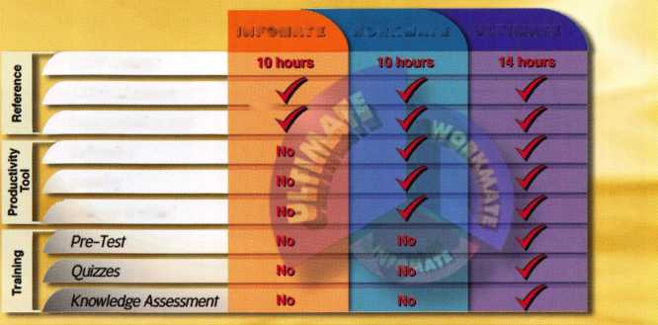

**JUNE ■ MAY ■ APRIL ■ MARCH ■ FERUARY ■ JANUARY ■ DECEMBER**

u p c o m i

Register by November 1st!

California Locksmith Association/ ALOA San Diego Chapter Locksmith Classes Town and Country Hotel, San Diego

Contact [SDCLAALOA@yahoo.com](mailto:SDCLAALOA@yahoo.com)

11-13

Winter Meeting, Education Classes and Annual Banquet Day's Inn Casper, WY Reservations (307) 234-1159 Class Information: Gene Ficek, CPL (605) 642-4542

|  |  |
| --- | --- |
| 1  San Diego Chapter of ALOA/CLA Educational Classes & Holiday Party Towne & Country Hotel  Hotel Circle North, San Diego  RSVP Chris Reuback (858) 273-0320 | 14  PRP • Dallas, TX • Ashley Manson (800) 532-ALOA (2562) [education@aloa.org](mailto:education@aloa.org) |
|  |
|  | |
| 19-20  ACE Classes • Foreign Auto  Butte, MT • Montana Chapter of ALOA • Todd Rasmussen, CRL 406-883-2950 • 406-883-2950 | 21-26  ACE Classes • Basic Locksmithing Appleton, Wl • Fox Valley Technical Jerry Antoon • 920-735-2406 920-735-2414 • antoon@foxval- 1 eytec h. co m www. foxva 11 eytec h. co m |
|  |  |

PRP • Dallas, TX • Ashley Manson (800) 532-ALOA (2562) [education@aloa.org](mailto:education@aloa.org)

12-17

TLA Convention, at Omni Hotel - Richardson, Texas. For more information: Michelle Spears 979-297-2413 [www.texaslocksmiths.org](http://www.texaslocksmiths.org)

1

16

PRP • Georgia Chapter of ALOA 10 a.m. • Chamblee, GA Contact John Elliott, CML, CPS 770-309-7574

PRP • Dallas, TX • Ashley

(800) 532-ALOA (2562)  
[education@aloa.org](mailto:education@aloa.org)

8-13

PRP* SAFETECH 2002 • Reno NV Contact ALOA • (800]532-2562 or (2]4|827-SAFE (7233) [www.safta.org](http://www.safta.org) • [dialcenter@aloa.org](mailto:dialcenter@aloa.org)

5-7

ISC EXPO/West at the Las Vegas Convention Center in Las Vegas, Nevada. For more information: http:// [www.iscwest.com](http://www.iscwest.com)

1

18-21

PRP*20 ACE Classes and PRP Somerset, NJ Dan McGlynn, CML 973-267-8884 973-538-1588 [dfmcml@home.com](mailto:dfmcml@home.com) [www.mlanj.com](http://www.mlanj.com)

1

18-23

ACE Classes • Basic Locksmithing Appleton, Wl • Fox Valley Technical Jerry Antoon * 920-735-2406 920-735-2414 • [antoon@foxval- leytech.com](mailto:antoon@foxval-leytech.com) • [www.foxvalleytech.com](http://www.foxvalleytech.com)

19-21

Minnesota Chapter of ALOA  
PRP Education weekend,  
Maplewood, Minnesota.

For more information:

Michael Mattern, CRL  
(952) 544-3399

10

PRP • Dallas, TX • Ashley Manson

(800) 532-ALOA (2562)  
[education@aloa.org](mailto:education@aloa.org)

14

PRP • Dallas, TX • Ashley Manson (800) 532-ALOA (2562)



n 9

15

GPLA 2001 Holiday Odyssey Party Rose Brier Inn 8828 Frankford Ave.

Philadelphia, PA

RSVP Bob Mock (215) 863-0710



**events**

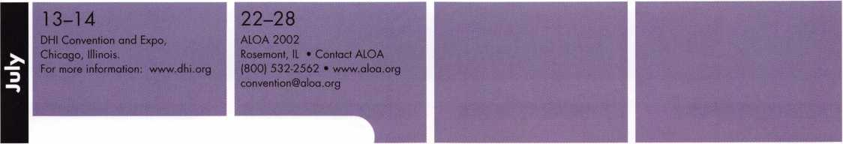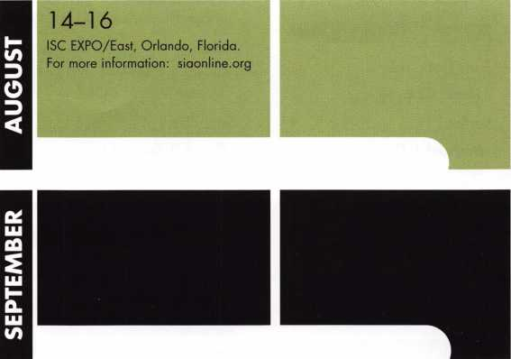

14-19

ACE Classes • Basic Locksmithing Appleton, Wl »Fox Valley Technical Jerry Antoon • 920-735-2406 920-735-2414 • [antoon@foxval- leytech.com](mailto:antoon@foxval-leytech.com) • [www.foxvalleytech.com](http://www.foxvalleytech.com)

23-27

GPLA Convention

October 23-27 (with Sunday PRP)

Philadelphia, PA

Contact: Marty Arnold, CML

Don’t Miss these  
ALOA Events!

DECEMBER 14, 2001

PRP • Dallas, TX • Ashley Manson • (800) 532-ALOA (2562)  
[education@aloa.org](mailto:education@aloa.org)

JANUARY 19-20, 2002

ACE Classes • Foreign AutoButte, MT • Montana Chapter  
of ALOA • Todd Rasmussen, CRL 406-883-2950  
406-883-2950

JANUARY 21-26, 2002

ACE Classes • Basic Locksmithing Appleton, Wl  
Fox Valley Technical • Jerry Antoon  
920-735-2406 • 920-735-2414  
a n too n @foxva 11 ey tec h. com www. foxva 11 ey tec h. co m

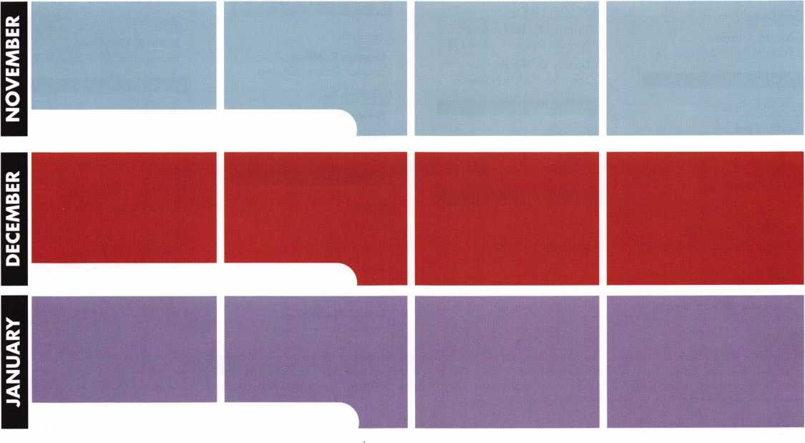

Alaska

Anchorage

Lynn Rock

Alabama

Dothan

William Ivey

Sponsor: James D. Turner Jr, CML

Gadsden

Allen Ragan Vestavia Hills

Joseph D. Box

Sponsor: Shelton A. Cummings

California

Fullerton

Harold Schroeder

Sponsor: Julie McCluney CRL

La Jolla

Walter D. Hofmann

Sponsor: Burt Fieser

Lompoc

Timothy L. Stevens

Sponsor: John H. Linn

San Bruno

Peter C. Carey

San Diego

Jon M. Gordon

Sponsor: Denise M. Lopez CRL

Colorado

Colorado Springs

Josh Dyer

Sponsor: Richard L Dyer CRL,RST

Loveland

Dean W. Meyer

Olathe

James W. Gale CRL

Sponsor: Richard D. Bernatis CRL

Pueblo

Marc A. Petros

Sponsor: Raymond E. Beggs CML

Florida

Hudson

Michael Dehner

Maine

Jefferson

Patrick J. Brewer

Hawaii

Kamuela

Nara K. Straus

Sponsor: Earl M. Tokuda



Colona

Scott A. Brandom

El wood

Christopher A. Bourg

Sponsor: Robert W. Oestreich RL

Joliet

Thomas D. Dunn

Sponsor: Robert W. Oestreich RL

Kansas

Topeka

William J. May

Louisiana

Baton Rouge

Ken M. Rills

Denham Springs

Tommy F. Hollomon Jr

Sponsor: Randall R. Jones CRL

Danny G. Harris

Sponsor: C Allan Halverson

Massachusetts

Randolph

Barry McMenimon

Sponsor: David G. Seeley CPL, CPP



Capitol Heights

Lawrence Hagans

Sponsor: Michael B. Groves

Farmington Hills

Jesse Kippola

Redford

Michael J. Dussia

Sponsor: Robert M. Massard CRL,AHC

Richard A. Karath

Sponsor: Robert M. Massard CRL,AHC

Ron S. Garason

Sponsor: Robert M. Massard CRL,AHC

Mississi

Picayune

Lawrence J. Barnes

Sponsor: James A. Bennett Sr; CML

North Dakota

Fargo

Robert A. Bentz

Sponsor: Todd K. Ladwig CML

New York

Deer Park

George R. Miller

Sponsor: Richard Grudens

La Fargeville

Dawn Smith Saint James

Robert W. Debetta

Sponsor: Richard Grudens

Ohio

Dayton

Carol M. Haag

Independence

Anthony Woronischtsche

Mansfield

Dan Billheimer

Sponsor: Robert R. Turner



Portland

J Pat Bieker

Sponsor: Clyde C. Williams II, CRL Salem

Roger J. Olfert

Sponsor: William F. Curtis

Scappoose

Daryl D. Brought

Wood Village

Ulises Estupinan

Texas

Abilene

James C. White

Amarillo

Ricky E. Goforth



Woodbridge

Troy G. Mitchell

Sponsor: Philip A. Rovenolt CPL

Wisconsin

Green Bay

Rick Hill

Oregon

Justin R. Gardiner

Sponsor: Michael B. Stilwell CRL

Japan

Kanagawa

Yukihiro Igarashi

Sponsor: Kazuma Ohno

Tokyo

Shinichi Shimayama

Sponsor: Keizo Takahashi CRL

Yokohama-City KanagawaKe

Hiroshi Yoshiwara

Sponsor: Takashi Kuwana CRL

The following applicants are scheduled for clearance as members of ALOA. The names are published for member review and comment within 30 days of this Keynotes issue date, respectively, to ensure applicants meet standards of ALOA's Code of Ethics. Protests, if any, should be addressed to the Membership Department and must be signed. Active Membership applicants (a) have worked in the industry two or more years. Allied Membership (AL) applicants are not locksmiths, but work in a security-related field. Apprentice Membership (AP) applicants have worked in the industry less than two years.

Keynotes

**Renew or Apply for Membership ONLINE at [www.aloa.org](http://www.aloa.org)**

**During times of crisis, unity is key. Right now, when you join ALOA  
(or renew your membership), you will receive, free of charge,  
this patriotic decal for your shop or van, which serves as a  
special reminder to you and your customers that it takes  
a spirited effort to strengthen the ties that bind us.**

AIOA Locksmiths (St Secure America %%

**Decal dimensions 8'/2" x 57V**

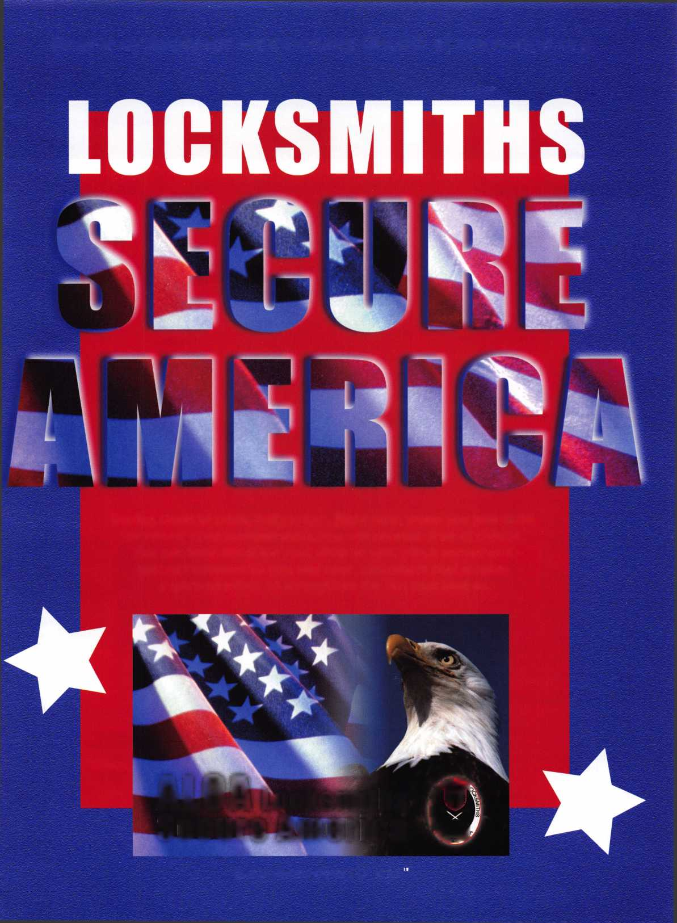

**" core**

Diebold Buys Mosler

Diebold, Incorporated recently announced it has finalized a deal to purchase select properties and operations of Mosler, Incorporated, in the United States and Canada, including physical and electronic security assets, currency process­ing equipment, certain service and support activ­ities, and related properties of Mosler for approximately $28 million.

The agreement includes the purchase of all intel­lectual property, the central monitoring station in Cedar Rapids, Iowa, security product design and tooling, existing service inventory and cer­tain real estate with an expected net book value approximating the purchase price. When fully integrated these assets could add up to $100 million per year to Diebold revenue.

Mosler, Incorporated was a leading integrator of physical and electronic security systems, monitor­ing services, support and maintenance, offering a comprehensive line of electronic and physical security systems to secure physical premises, manage access, monitor events and process cur­rency. Mosler tailored its solutions to financial institutions, government facilities and a wide range of commercial and industrial market seg­ments. Company officials recently announced that Mosler would cease operations and file for Chapter 1 1 bankruptcy.

Diebold, Incorporated is a global leader in pro­viding integrated self-service delivery systems and services. Diebold employs more than 1 2,000 associates with representation in more than 80 countries worldwide and headquarters in North Canton, Ohio, USA. Diebold reported revenue of $ 1.7 billion in 2000 and is publicly traded on the New York Stock Exchange under the symbol 'DBD.' For more information, visit the company's Web site at [www.diebold.com](http://www.diebold.com).

Comdex New Products

Selling products that guard against terrorism and fraud is the way to get noticed at this year's Comdex computer convention. This year, many are betting that the event belongs to tiny security cameras, eye and fingerprint scanners and anti­hacking software. Among the pitches:

* Panasonic is heavily promoting its iris recogni­tion camera, along with the DVD players and video cameras the company is better known

for. The "Authenticam," which is a little small­er than a paperback book, uses the shape of a person's eye for identification. It sells for $239.

* EDS will be demonstrating a security system currently used at a Tel Aviv airport. The Plano, TX, information-services giant plans to focus on security issues during the entire conven­tion. It will also introduce three privacy servic­es for businesses.
* Siemens, a German electronics firm whose products range from turbines to medical equipment, is promoting an identity-sensing computer mouse. The $119 "biometrics mouse" has an embedded fingerprint scanner that can help determine the identity of Web surfers.

Mailbox

Here in the recent past, because of the events of Sept. 1 1, we who are in the trenches have been feeling a lot of pressure. In short, every­body has gone paranoid and as a result we're getting the heat.

Here in the past week or so, I've had to listen to numerous complaints about how scared people are. Because for the first time in their lives, the terror is coming right in their back door. My message to those people is that it just ain't so - so please get over it.

Though the media overplays it, it seems we in the trenches are stuck between a rock and a hard place. So what must we do to get through this? An old saying comes to mind, and it goes like this, "When all around has gone to hell in a hand basket, it's time to get back up, regroup and let calmer heads prevail."

In short, keep a level head, even when those around you don't. I've had to stress this with some of the people I deal with, and that also includes security people. It hasn't been easy.

I've also noticed that in the past few issues of Keynotes, you have published some very perti­nent information about all the events; at times like this, that information is greatly appreciated. Many of my clients are wanting to upgrade their systems, and the timely information in Keynotes is very helpful.

Sincerely, James Alridge

|  |  |
| --- | --- |
| New Certifications | |
| CRLs | |
| Michael Aug | Elmire, NY |
| William Blanchard | Portland, OR |
| Eric Costley | Waverly, NY |
| Mark Fuller | Elmira, NY |
| Ky Hume | Anchorage, AK |
| Daniel King | Bremerton, WA |
| Karl Kretsch | Springfield, OR |
| Fred Martin | Victor, MT |
| David Noye | Grand Forks, ND |
| James Peppin | Mora, MN |
| Dennis Petrin | Clackamas, OR |
| Ronald Smith | La Fargeville, NY |
| Kuwana Takashi | Kagawa, Japan |
| Thomas Tate | Pensacola, FL |
| Jack Townsley | Douglasville, GA |
| Steven Tucker | West Palm Beach, FL |
| Russell Turner | Pensacola, FL |
| Royce Welch | Alto, NM |
| CPLs | |
| Scott Henke | Anchorage, AK |
| Clay Howard | Wenatchee, WA |
| Lynn Johnson | Fargo, ND |
| William Peters | Knoxville, TN |
| CMLs | |
| Ronald Lasseter | Miami, FL |

In Memory

ALOA member Harold F.  
Doan, Sr. (member  
1 2235) passed away on  
Sept. 22, 2001, at the  
age of 85. Harold was  
a member of ALOA and  
The Ontario Association  
of Locksmiths for many  
years.

He was actively working up to the time of his  
admission to hospital in mid July. He returned  
home in early August, and even as he grew  
weaker, he still offered advice and guidance.

The business continues to serve Orangeville  
and surrounding areas as Harold Doan and  
Sons Ltd., under the management and operation  
of his two sons and daughter: Harold (Jnr), Jim,  
and Ruby.



Keynotes

|  |  |  |  |
| --- | --- | --- | --- |
| t3.PuMc.bon Tib. | | 14. issue Date for Ocuteton Orta Below  Nov&nber 2001 | |
| Extent and Katun of Circulation | |  | Ho. Copies of Single tesus Published Neerest to Filing DaU |
| ?  !  i  !  i  i | | 8,000 | 8,500 |
|  | Paki/Requested Outside-County Mai Subscription* Stated on Form 3541. (todudo adwfeart proof and exchange copes) | 6,996 | 7,994 |
| SouSon (3 | Sates Through Dorters and Carriers, Street Vendors, Counter Sates, and Other Noo-USPS Paid Distribution | 70  0 | 0 |
| (4 | ) Other ClasaosMrtiod Through thaUSPS | 0 | 0 |
| c Total Paid and/or Requested Circulation w  ISum of 13b. (1% m,(3)*nd (4)J V | | 7,066 | 8,063 |
| Distribution (1 | ) Outside-County as Stated on Form 3541 |  |  |
| by Mai  (Samples. (2 | ) In-County as Stated on Form 3541 |  |  |
| <a | ) Other Classes Mated Through the USPS |  |  |
| » Free Distribution Outside the Mai | | 600 | 9 |
| Totoi Frss Djatrbution fSum of ISd. end 150.) ► | | 600 | 9 |
| 8 Total Dtebfeubon (Sum of 15c and 15f) ► | | 7,666 | 8,072 |
| Copies not Distributed | | 3 34 | 428 |
| Total fSum of ISg. end h.) ^ | | 8,000 | 8,500 |
|  | | _22.,t 7 . * | 99.892 |



instructions to Publishers

as where the stockholder or security holder is a trustee  
the trustee is acting. Also include the names and addr

re of the total amount of bonds, mortgages, or other securities of the publishing corporation.

*■*—*■ *•-—*- “ —re space is required

of the person or corporation for

bos. Use blank sheets if r

Dn Form 3541, and returned to the publisher.

in October or, if the publication Is not published during October,

In Item IB. indicate the date o( the issue in which this Statement ot Ownership will be published Item 17 must be signed.

Failure to hie or publish a statement of ownership may load to suspension of Periodicals at

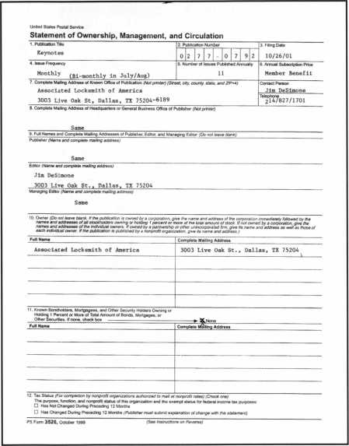

“Weighs” in BIG!

Enjoy the new technology from ABUS!  
Using the 83 Series Pinning Window™ Cylinder!

Unique  
“Tear Drop

Design

* Yale 8®
* Kwikset(
* Schlage C
* Schlage C-L
* Corbin
* Sargent*
* Arrow
* Russwin
* Weiser- Falcon
* Z-Bar

Order the HEW “83/55” in any keyway from

your distributor! Receive a FREE ABUS ($7.99)

Trigger Lock for each # 83/55 ordered! That’S a 55% Savings!

OLDER

**HURRY** while supplies last! Promotion ends—Dec. 31, 2001

For ordering information:

ABUS Lock USA 1-800-352-2287

Keynotes

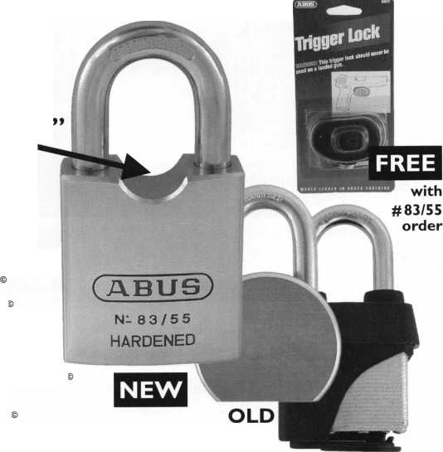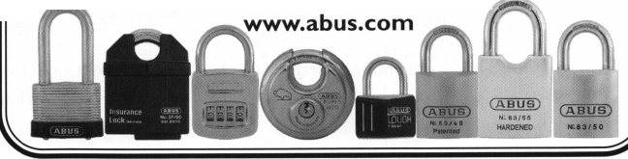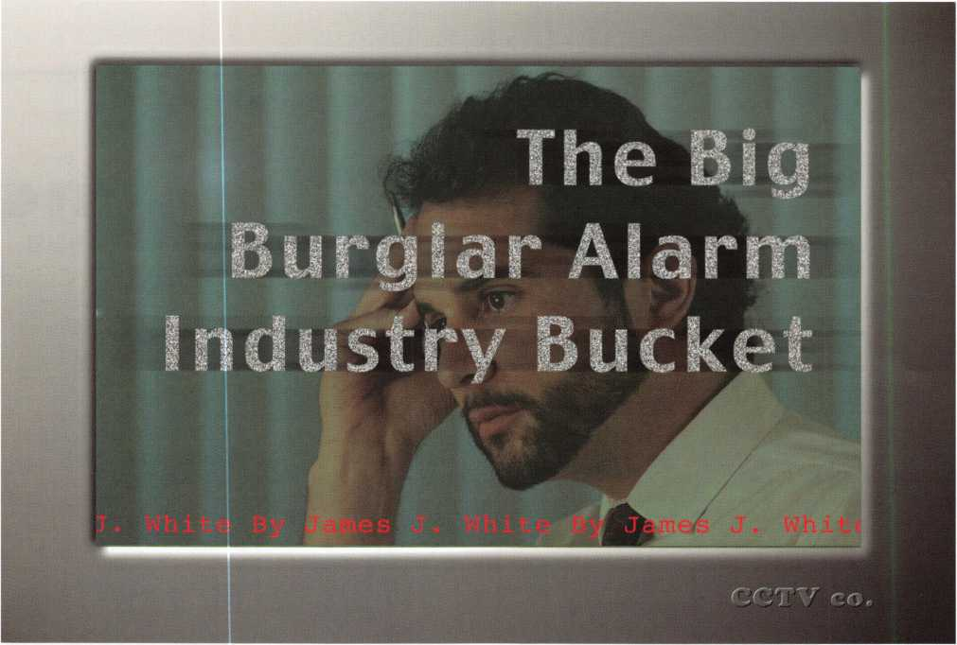

After a grueling io-hour locksmith type day, I returned to my office to face yet another foe, the burglar alarm industry.

I was first welcomed by the sound of my own business alarm that somehow went off even though I turned it off as I have every day for the past seven years. You know, the burglar alarm I had to pay someone else to install? In Illinois, you need a Locksmith license to be a Locksmith and Burglar Alarm License to install burglar alarms. If I install a burglar alarm, it is illegal! After 20 minutes on the phone with the alarm monitoring service in another country, I finally convinced them I was not robbing Fort Knox.

I was looking forward to a night with my family and went to my office to call them and tell them I was on the way home. Next to the phone on my desk was a Keynotes Magazine opened to a page with information on a new Illinois amendment that was trying to be passed pertaining to including Closed Circuit Television systems in the burglar alarm industry licens­ing. Someone had left the article for me to ponder.

How, on God’s beautiful shining earth, can someone even mention Closed Circuit Television Systems in the same breath as burglar alarms? I have never heard of a CCTV camera summoning law enforcement; I have never punched in a code on a key-pad to arm or disarm an alarm on a 24-hour security video recorder, and if there is a multiplexer, quad processor or switcher that can call a monitoring system in another country to argue about my false alarm, I sure would like to see it!

I sometimes wonder what is next. Maybe in the not too distant future, installing deadbolts will try to slip into the burglar alarm industry. How about duplicating keys, opening safes, changing safe combinations, pushbutton entry locks and access control? Let’s throw every service we locksmiths have perfected over the last 100 or so years right into the big bur­glar alarm industry bucket. We can all become janitors and sweep up after the alarm industry installers day in and day out. Next they will want to include selling hot dogs and nachos as a service only they can provide.

I am also puzzled by this fact. I am not personally aware of any large national locksmith company like the alarm compa­nies have. Most of our locksmith businesses are locally owned and operated. We do not want to monopolize, or manipu-



Keynotes

late their industry. We could care less about what they do or how they do it. Locksmiths are not concerned with the alarm industry’s success. Why do they con­stantly want to strip us of some of the services we provide, just as well or better than they can provide them? Ever heard of sharing the wealth? Let us make a living too.

When an alarm company found out our company did access control, they quit sub-contracting me for the installation of electric strikes. They never called me again. I could never figure out why this big national company with all this state-of-the-art panels, con­trollers, keypads, glass break detectors had to call the itsy-bitsy local locksmith to install an electric strike in the first place. Another alarm company who we bid against told a customer that my company was not licensed to install a card reader on their front door.

And tomorrow, when I get a call from someone inquiring if I install burglar alarm systems, I will have to inform them I am not licensed to do that type of work and refer them to a local alarm company with whom I have built a good relationship. This alarm company refers me and I refer them. We work togeth­er as a team. We share our wealth. They do things I can’t do and I do things they can’t do. They accept it and I accept it. Pretty simple.

I urge all locksmiths to stay on top of new legislation, not only in your own state, but across the country. Support one another in this battle with the alarm industry. One day, you may encounter something like this. I just wrote a letter to the Governor of Texas on an issue very similar to the CCTV issue we had in Illinois. Remember when your fiercest competitor was another local locksmith? Times have changed. Now, I would have all my local locksmith competitors over for dinner. We’re all in this together.

My frustrating io-hour day became an 18-hour day after researching the amendment, and writing this article. And tonight before I retire, I am again reminded of the burglar alarm industry as I arm my home burglar alarm system I couldn’t install there, either. Press and hold four to disable the hallway and living room motion, OK?Q

Quality • Price Delivery

ivar*

KILLEEN SECURITY  
PRODUCTS

INTERCHANGEABLE *CORE PRODUCTS*

Interchangeable with:

•BEST

* ARROW
* FALCON

That's what KSP is all about!

***33 Hernton St***.

Ask your wholesaler about  
our drop shipping**.**

***Worcester,*** IH4 ***01610  
Phone (508) 798-3200  
Fax (508) 753-2183***

HARDWARE FOR THE NEW Ml

Oxford, Ml 1-800-522-2940 * Charlotte, NC 1-800-768-6050 *

[www.jlmwholesale.com](http://www.jlmwholesale.com)

Order Online ~  
Cjet Tree Treiyht!

%st a cficl away fromyour

security door hardware needs:

[www.jlmwholesale.com](http://www.jlmwholesale.com)

TOehsite ^features:

Detailed product information.

Search capabilities on each page. Check box to display only in stock items. New quick links. Extremely user friendly. Downloadable interactive product catalog.

Keynotes

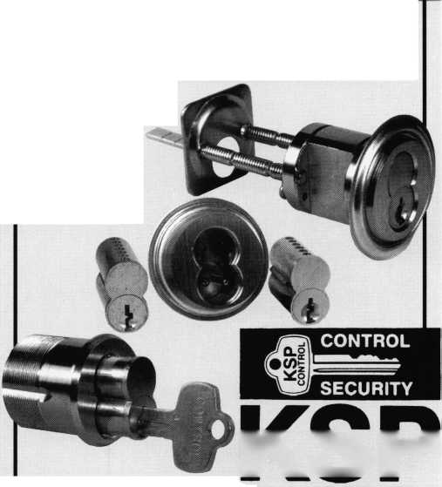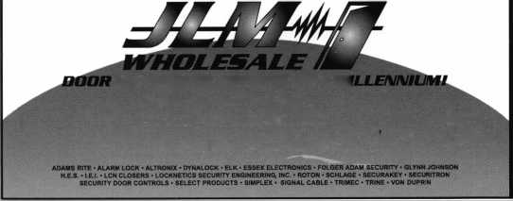

**from Lockmasters**

Keynotes



he holidays are the perfect time to stock up on tools, and Lockmasters is never short on  
tools. Now is the time to figure out which tools work best for you, because another year  
with the wrong equipment and you might flip your proverbial lid.

Tools, as they go, are the locksmith’s best friend - or his worst enemy; making fast work  
of the most difficult job, or making a disaster of the simplest task. And, when it comes  
to tools, making the job easier has been Lockmasters’ goal from the very start.

Seated in a unique position as both a distributor and manufacturer, Lockmasters began

by focusing their entire efforts on bringing quality safe tools to the locksmith. Today, they’re duplicating this  
success in the automotive and locksmith tool lines. Following are just a few of the tools they’ve brought to  
market over the last year.



High-Security Flip Pick

Until recently, opening a 2- or 4-track high-security  
BMW was an accomplishment attempted by only a few  
ardent automotive locksmiths. Bypassing or overcoming  
BMW’s notorious “deadlock” feature sent most locked  
out BMW owners back to the BMW dealer. Even here  
few options were available. Typically, the customer would  
be asked to wait a few days while new keys were ordered.  
If that wasn’t feasible, the dealer was left with either  
breaking and replacing a window or drilling the deck  
lid or trunk.

The LKM2690 High-Security Flip Pick, however, brought opening BMWs back to the locksmith. Originally  
designed by Master Automotive Locksmith Randy Mize, the Flip Pick in the hands of a locksmith often can  
affect a BMW opening in just a few seconds. And because the opening is made via picking the door lock, the  
vehicle’s security system is deactivated and the likelihood of causing damage to internal lock linkage is eliminated.

Using the Flip Pick is also quite easy to learn to use. Simply insert the tension wrench into the door lock’s shut-  
ter unit. Then insert the picking blade. Using the tension wrench, apply just enough pressure towards the lock  
direction to bind the tumblers in the up position and remove the picking blade.

Then, gently release the pressure on the tension wrench, allowing a tumbler or two to snap into position.

Once the first snap is heard or felt, rotate the tension wrench towards the lock direction. If the lock does  
not turn, again release enough pressure on the tension wrench to allow another tumbler or two to drop.

Repeat this process until the tumblers have dropped and seated at the shearline, and the lock turns to the  
locked position.

Once the lock is in the locked position, use the heavy-duty plug spinner to spin the plug back to the unlock  
position, unlocking the door.

With the success of the BMW pick, additional picking blades were soon added to open the high security  
VW/Audi/Porsche (LKM2694), the high security Saab (LKM2696), and Mercedes 2-Track (LKM2699).

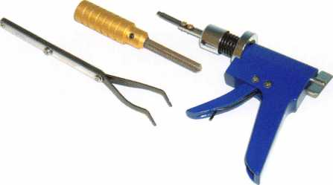

Lockmasters' LKM2690 High-Security Flip Pick put BMW openings  
back in the hand of the locksmith.

Keynotes

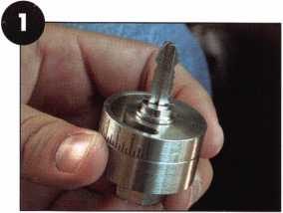

The key blank serves to hold and orientate

the Lynch-lt on the ignition lock.

Once inserted on the lock, the index mark

is rotated to the drill point.

We begin drilling.

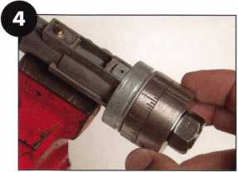

A better view of the drilling operation.

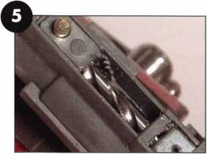

Use a standard high-speed drill bit  
to make the first plunge.

The carbide bit finishes the job.

Lynch-It

Designed by locksmith Tom Lynch, the L2034 Lynch-It is used to quickly drill and  
remove the push-button retained import locks, including many from Toyota, Lexus,  
Isuzu, Mitsubishi, and more. As a bonus, this same tool can be used for quickly drilling  
and removing Medeco, Mul-T-Lock, Miwa and other brands of rim and mortise cylin-  
ders. Although many companies manufacture drill guides for removing various types  
cylinders, the Lynch-It is unique in that it not only fits import automotive locks but it  
is also adjustable.

When removing a lock, the outer disk or ring of the tool is dialed to a given index  
number, aligning the drill point of the lock’s retainer. Although two hardplate rated  
carbide drill bits are provided, we’ve found it best to start the drilling using a standard

high-speed drill  
bit, reserving the  
carbide bits for  
removing the  
hardened retainer  
button.

We used this tool on a 1997 Toyota Camry. We began by fastening a key tip or key stub into the tool. (See photograph 1.)

The key serves to hold the tool in the lock, provid­ing the correct

orientation for aligning the drill point. (See photograph 1.) Once the key tip is secure, the tool is inserted into the ignition and the outer disk is turned to align the index mark with the proper dill point as described in the user manual. (See photograph 2.)

Using a standard high-speed drill bit, we began drilling for the retainer button. Due to the proximity of the steering wheel to the lock, we used a right angle drill to perform the drilling. (See photograph 3.)

To give you a better idea of what is being accomplished, we drilled the lock while in a vise. (See photograph 4.) As seen in the photographs the regular drill bit is used to gain access through the front of the lock, and right back to the retainer button. (See photo­graph 5.) Once the retainer button is reached, the carbide bit is used to remove the but­ton, allowing the lock to be removed from the housing. (See photograph 6.)

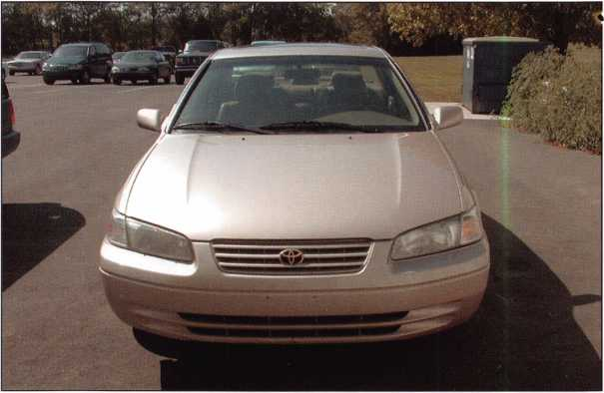

The L2034 Lynch-It will make fast work of the ignition on this  
1987 Toyota Camry.

Aside for the quick removal, another nice feature of this tool is that it does not destroy the lock’s plug. By preserving this portion of the lock, the plug can be removed for gen­erating a new key or providing the correct bitting for keying the replacement lock.

m

m Keynotes

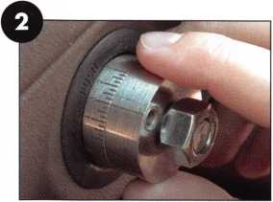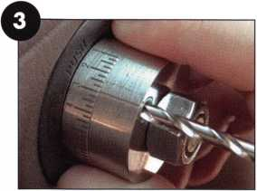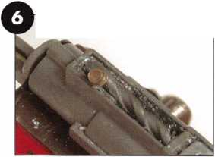

^ Hook Tool

I can see it, but I just can’t reach it!

From keys sitting on the front seat of a locked vehicle, to the thumbturn just out of reach  
of an opening tool, this is one line mumbled more than once by locksmiths all over.

To ease the aggravation, Lockmasters just recently introduced the LKM2300 Adams Rite  
Hook Opening Tool. Destined to be labeled one of those tools that “I should have thought  
of,” the LKM2300 is used to access and rotate the thumbturn on double aluminum stile  
storefront doors.

We began testing this tool by using an air wedge to spread the doors, giving a little more  
room for the tool to enter. (See photograph 9.) The tool was then inserted between the  
doors and the forked end placed over the thumbturn. (See photographs 10 and n.)

Once in place, the handle of the tool is turned, rotating the thumbturn and unlocking the  
door. (See photograph 12.)

Mercedes Drill Kit

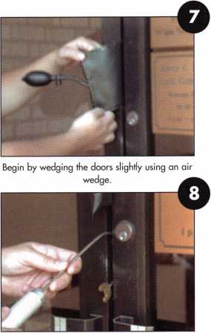

Insert the tool through the two doors...

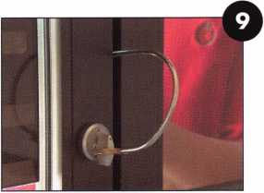

And place the forked end over the thumbturn.

My first Mercedes ignition removal was accomplished in six hours using a Dremel moto-  
tool. Needless to say, if I wanted to make money, I’d need a faster method for removing  
this often failed lock. So, I upgraded to a 1/4” electric die grinder - effective, but messy.

Now, more than 15 years later,

Lockmasters introduces the LKM1124  
Mercedes Drill Kit. Used for removing  
the Mercedes single poke hole ignition,  
the LKM1124 is a compact kit that

includes a drill guide and two safe hardplate rated carbide drill bits.

As lock removal is quite simple in premise, we gave this tool a whirl  
through one of our bench tests. To remove a working lock, a key is  
used to turn the lock and align the access holes for depressing the  
lock retainer. Once aligned, a thin probe is inserted into the hole,  
depressing the lock’s retainer. With the retainer depressed, the bezel  
can be unscrewed and removed, allowing the lock to be removed from  
the housing.

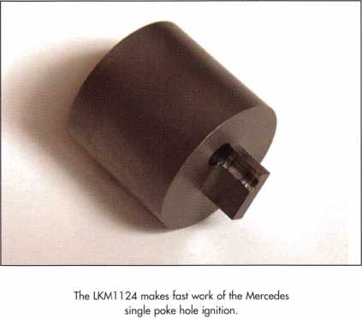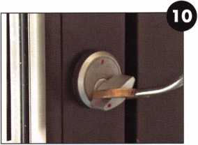

Turn the handle to rotate the thumbturn and  
unlock the door.

In a typical lock failure, even a newly code cut key will not turn the lock, thus, there is a need to access and depress the retainer. Although drilling has always seemed like the fastest way to go, the challenge begins in trying to get through the hardened faceplate of the Mercedes lock. In the past, Dremel moto-tools and diegrinders with cutting blades and grinders were the fastest mode of attack. But with the LKM1124, not only is the job much cleaner and controlled, but removal time is often less than 5 minutes.

Using the tool is almost self-explanatory; we placed the drill guide onto the face of the ignition lock and started drilling using the 3/16” x 4” carbide drill.

Keynotes

In less than two minutes, we had an access hole drilled through the lock’s hardened faceplate. About the only trouble we had to this point was when the drill bit started breaking through the back of the facecap. The uneven backside of the faceplate caught the hardened cutting edge of our first drill and broke the tip. Our approach with the second drill was a little more cautious and it finished the facecap still intact and ready for the next lock.

Just to stretch the use of the bit a little more, we continued to drill into the softer zinc diecast metal of the lock plug and case. The drill cut through it quite easily, but had to be removed and cleaned frequently. We finished with a standard high­speed bit, drilling out a large cavity just below the lock’s retainer.

When enough material was removed, a large screwdriver was used to forcibly spin the facecap, aligning the retainer’s access hole in the facecap with the access hole on the lock case. Once aligned, a thin punch was inserted and tapped to drive the retainer down into the cavity we created.

The bezel was now free to spin off of the lock, and the lock removed from the lock housing.

^MCR

Our final tool is the Magnetic Clip Remover. For anyone familiar with the small spaces and sharp edges found in removing  
the automotive door lock retaining clips, this tool is a gem.

In short, this tool is used to remove the door lock clip from most (if not all) automotive door locks that are not part of the  
handle. It works on both horizontal and vertical clips. Once the clip is removed, the lock can be serviced and the clip replaced  
- all without removing a door panel.

To use, lower the window on the door with the affected lock.  
Use the provided wedge to provide a little more room to  
access the clip area. Next, place the provided earth magnet  
in a rag and place it on the door, just over the location where  
the clip is to be removed.

Using one of the two provided clip pulling tools, work the  
door clip loose and slide it off of the lock. The strength of the  
magnet will hold the clip in place. Remove the lock and repair  
or replace with a new lock. With the lock back in place,  
maneuver and seat the clip back over the lock.

You’re done! Q

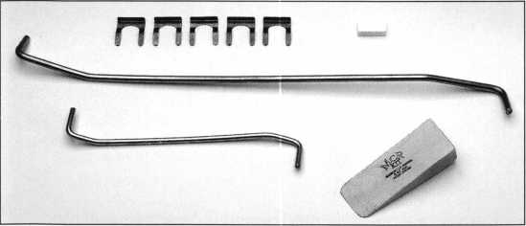

The MCR tool makes fast work of standard automotive door lock removal.

Keynotes

**Assemble Lynch-lt Tool**

FEATURING THE

AUTOMOTIVE DRILL GUIDE

Ignition lock removal has never been so easy. Quickly locate and remove  
the retainer pin on the most common import vehicles including Toyota,  
Isuzu, Mitsubishi and more. The Lynch-lt (L2034) drill guide easily aligns  
the drill point for gaining access to each lock's retainer.

Now join Lockmasters Inc. as we tour the U.S. with our

**Insert tool onto lock**

AUTOMOTIVE WEEKENDS!

From the basics to the latest in

**HIGH-TECH AUTOMOTIVE LOCKSMITHING,**

get your fill of Transponder Technology, Auto Opening, High Security Automotive, Key Generation and the newest tools to do the job fast!

|  |  |  |  |
| --- | --- | --- | --- |
| ^5 2001-2002 PUREAuto | | U.S. TOUR DATES | |
| Jan. 2002 | Orlando, FL | June 2002 | Somerset, NJ |
| Feb. 2002 | San Francisco, CA | Aug. 2002 | Atlanta, GA |
| May 2002 | Chicago, IL | Sept. 2002 | Anaheim, CA |

For additional information on the dates & locations of the  
PUREAuto Automotive Weekend nearest you, contact  
LOCKMASTERS at 800.654.0637.

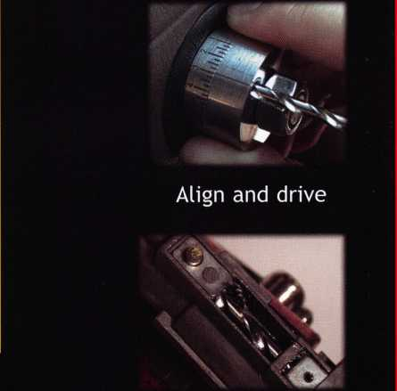

**Drill through face cap  
towards retainer**



**IOCKMASTERS**

INCORPORATED

**5085 Danville Road • Nicholasville, KY 40356  
859.885.6041 • Fax 859.885.7093**

**800.654.0637  
[www.lockmasters.com](http://www.lockmasters.com)**

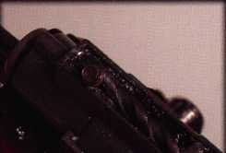

**Drill retainer and  
remove lock.**

WE HAVE IT AIL.

AUTOMOTIVE, LOCKSMITH TOOLS a SUPPLIES • KEY MACHINES  
CAR OPENING TOOLS • MANUALS a EDUCATION

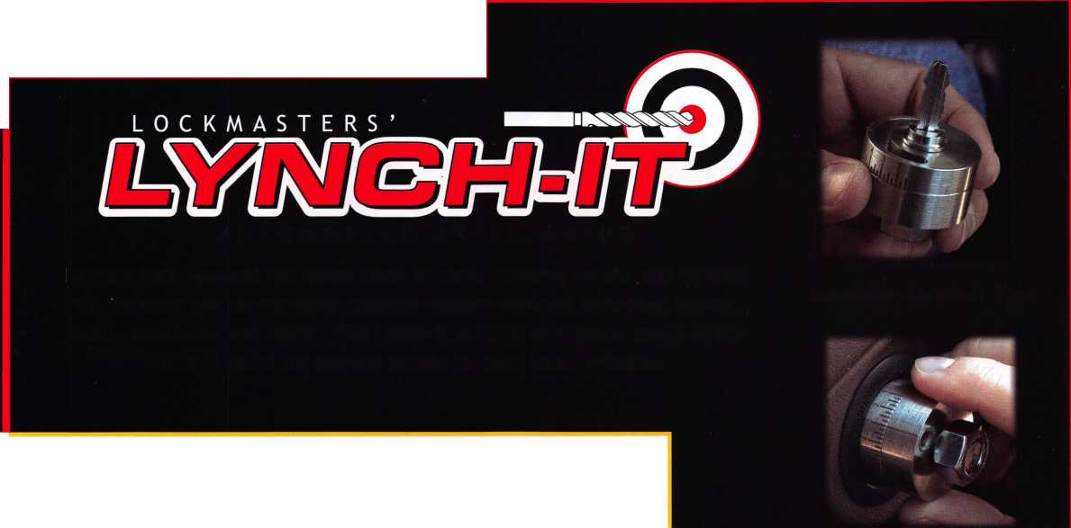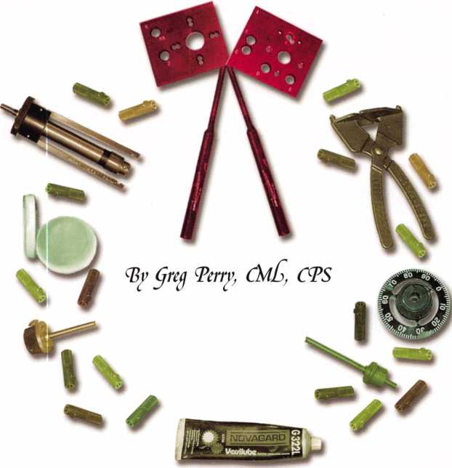

So you want to start opening and repairing safes? It’s often said that anything man can make, man can also defeat. So with enough talent, time and tools, any safe can be opened. All three are very interrelated. If you lack the knowledge of how the safe is constructed, the time needed to open the safe will probably increase (if you can even open it all). Without a sufficient amount of time, you will not open the safe. Not having the correct tools will slow you down or prevent you from opening the safe. Imagine trying to install a mortise lock with only a wood chisel. Could you do it? Would it take you longer? Would it be a professional-looking job? I doubt it. But if we add a drill with the right bits, we’re a lot closer to being able to install it correctly. Adding a mortising jig and a drill guide template increases the likelihood of a very professional installation in the fastest amount of time. By the same token, safe work requires the correct tools. This article will look at a recent safe opening and specifically the tools used to open this safe. If you decide to open safes and repair them some or all of these tools should be in your arsenal.

Keynotes

Shoving Off

Before starting with the tools that perform the work, Til discuss the most important safe tools, which are undoubted­ly education and reference material. Some information (such as a catalog) is free. Books and magazines may cost money, but to repeat a quote I’ve often heard, “If you think knowledge is expensive, try ignorance.” IVe been collect­ing information for 22 years. It includes manufacturers catalogs, pictures and dimensions of safes weVe sold or ones that IVe worked on, magazine articles and books. It also includes lots of notes and information off the Internet or from other safe technicians with whom IVe traded photos. Internet forums offer a great source of information and my personal favorite is Safe and Vault Technicians Association forum (<http://www.savta.org/forum.htm>). Please do not underestimate the value of education and information; it can save lots of time and headaches.

Sometimes the only tools needed to open a safe are our hands and sometimes a pen and paper in the case of manipu­lation or a stuck fly. I know many times after drilling open a safe IVe slapped myself on the forehead. I realized I did­n’t need to drill I just needed more patience, talent, or experience. Other times a full arsenal of drills, drill rigs, dial pullers, hammers, probes, punches, welders and other tools may be needed. Let’s go through this particular opening and look at each of the possible tools as we go.

Very Tough Gary

I used almost all the tools in my arsenal. The safe in question is a Gary TL-15 or TL-30 money chest. The customer, a market, called on a Sunday afternoon to say they needed into their safe now and it would not open. I had my young daughter with me on a house lockout so I figured on a quick dial open and home in time for dinner.

I was mistaken.

My first step was to use my hands, I tried the combination and found some very distinct contacts at “o” going right or left. It didn’t make sense; there should be a gap between the contact points. I checked the rest of the lock for wheel pick up and made sure the balance of the lock was, as near as I could tell from the outside, functioning properly.

I began to question whether a mounting screw was somehow jammed in the wheel pack giving me the feel at “o.”

It didn’t make sense to me. I decided to head home for an SAVTA Forum post on the Internet. The only response I received was from someone who also thought a mounting screw might be jamming the lever. I grabbed the balance of my safe opening tools and headed back to the job. I tried using a large rubber deadblow hammer to jar the screw loose with no success. Then I decided to drill.

Start Your Engines

My first step was to pull the dial. I used the puller included with my StrongArm MiniRig Pro Kit. It can be used in two different modes — either as a slam hammer or a press puller. Sometimes a pair of ViseGrip pliers can be used to wiggle the dial off the spindle. Once the dial is off the dial ring, screws are removed and the dial ring is set aside.

A hole location needs to be determined. I consulted my library; it includes pictures of this exact safe from a prior combination change. I decided to drill for the fence. Next we have a choice to make between free hand drilling, lever rig, fixed rig or magnetic base drill. Free hand drilling is out because the hardplate in a TL rated safe is too hard to drill freehand. Next up is a lever rig. We own a Keedex lever rig, but I prefer the control I have with a fixed rig like the MiniRig. We do not own a magnetic base drill. I choose the appropriate template from the StrongArm kit and mounted it using the dial ring screw holes. Now we need to choose a drill motor. Bosch Hornets used to be the drill motor of choice for most safe pros; unfortunately, they are no longer made. If you can find one, buy it. The hot new drill is the Metabo 751 drill. When I burn up my Milwaukee hammer drill, we’ll buy one. I started drilling with a 5/16-inch standard twist drill. I made it through the outer steel to the hardplate.

**Keynotes**

21

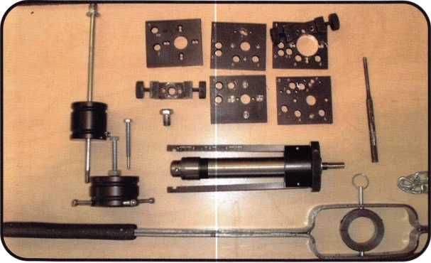

Now the fun starts. I chucked up a 1/4-inch StrongArm carbide bit.  
StrongArm seems to be the drill bit of choice today. I’ve tried ProLock,  
Keedex, Mr. Twister, Lockmasters MP-3 and I still like StrongArm the  
best. They get through more hardplate and faster than the rest. I keep  
a small stock of the other brands in case a particular hardplate succumbs  
better to one of the other brands, but I always grab a StrongArm bit first.

I started the drill and applied lots of pressure and high speed; the hard-  
plate laughed at my attempt. Next, I sharpened up my punch and alter-  
nated between drilling and punching. This method has been used in the  
past with success but it can be slow and painful. I’ve seen a some people  
use a io-pound sledge hammer with the handle cut down for single-hand-  
ed swinging. This is a difficult way to get a hole through the hardplate.  
After a short time of trying this method, I decided to break out one of  
the safecracker’s best friends: the diamond-core drill. These are expen-  
sive, but worth every penny when used properly. They also require a fixed  
rig. This was another part of my choice for the MiniRig. Having tackled  
a Gary hardplate in the past, I knew the diamond-core drills would prob-  
ably be used. Diamond-core drills require a different technique than car-  
bide drill bits. The recommended speed is 1000 to 1200 rpm with mini-  
mal pressure. Too much speed or pressure and the diamonds will strip off  
or the bit will mushroom. We own an inexpensive “Skil” drill motor  
model 6250 with a dial set speed control. This allows the user to set the  
speed at about 1100 rpm. The bit was brought up to the surface of the  
hardplate and the drill was started at a very slow speed. This gives the  
diamond bits a chance to even out the surface and not fracture as we  
start. Once the surface is smoothed out then the speed can be increased  
to 1100 rpm and a little pressure is applied until the drill slows down  
slightly. After the drill motor speeds up then a little pressure is applied.  
This process is repeated until the hole is 1/8-inch to 1/4-inch deep.

Next I cleared the hole using a 1/4-inch carbide.

In some cases the carbide will start cutting; other  
times it only clears out the center core and we go  
back to the diamond. This hardplate required about  
one hour to drill through the hardplate using a dia-  
mond bit. Once we have a hole through the hard-  
plate we need to penetrate the lock case. Northwest  
Safe and Vault provide a specially sharpened flat tip  
drill bit, which looks almost like an end mill. This  
allows the lock case to be penetrated without dam-  
aging the wheel pack. I drilled into the lock case.

Strong Arm MiniRig Attached to safe

Outside of safe after removing dial and ring

Time to Play

Anybody Home?

The Keedex lever rig is pictured on the bottom. My favorite rig is just above it. The StrongArm  
MiniRig is the best system for the beginner or advanced technician. The templates shown above  
give you pinpoint accuracy. To the left of the templates is the StrongArm dial puller. It can be  
used with the slam hammer or the puller bolts.

At this point, we needed something to look inside.  
Sometimes we use a flashlight or an otoscope, but  
most of the time, I use aborescope. We own two

22

Keynotes

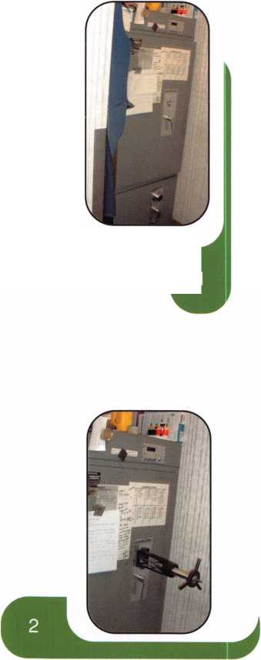

Hawkeye scopes, a 7-inch and a 17-inch scope. The 7-inch gets most of  
the work. Only if the 7-inch won’t reach when drilling from the side or  
top do I use the 17-inch scope. Other scopes are available from a range  
of prices — some being a little less expensive to the $5000 Storz swing-  
prism scope. I’ve found the Hawkeye to be the best value for the average  
or entry level safe technician. A good light source is very important.

The more you need to see, the more light you need. Light sources come  
in many shapes and sizes from the key chain light Northwest Safe and  
Vault to 150-watt projector light sources. This time, when I looked  
inside, the fence was not there. I lined the gates in the wheel pack up at  
my hole and could make out the end of a broken lever. I could see it  
drop into the gate of the drive cam, but the nose was missing. There was  
no way for the drive cam to pull the lever and the bolt up, unlocking the  
safe. I tried using a sharpened probe to lift the lever. I tried drilling  
a 1/8-inch hole in the broken end to again use the probe to lift, but  
couldn’t get the bit angled enough. I finally gave up and drilled a hole  
between the bolt and the wheel pack. This allowed me to probe the  
lever up. Finally, this safe was open. After it was open I found the fence  
and the lever nose in the bottom of the lock case. The casting of the  
lever had a flaw or void, creating a weak spot.

The Aftermath

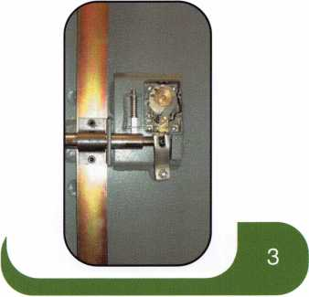

Inside view of safe with lever nose missing

Next we had to repair the safe. The best way is to weld the hole with a  
ball bearing or some carbide welded in the hole. Always try and make  
the repair stronger then the original material. This time I used one of  
the drill bits as filler and welded a bearing on each side of the bit.

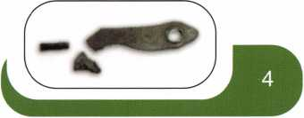

Our list of safe tools is not complete; we still have a few more to add.  
Canned air works great to keep the hole clear. We get ours from a  
company called Blow Off — you can find them at [www.blowoff.com](http://www.blowoff.com).

An emergency dial is useful when the original is missing. Several off-the-  
shelf models are made, or you can make your own.

Change keys for as many models of locks as you

work on can help, but these can add up to a sub-  
stantial investment so add them as needed. Ball  
buster bits are available from StrongArm for  
drilling ball-bearing hardplate. Assorted collections  
of music wire and welding rod can be used to make  
hooks and other tools. Cutaway locks on mounts  
are great learning tools and can be used for meas-  
urements and diagnosis. Dial ring alignment tools  
are available to properly align the dial with the  
lock case. As you get into electronic safe locks,  
then you should have wire spicing tools, a digital  
volt ohmmeter, and battery tester. A selection of  
keypads from the various manufactures is needed  
to replace a bro

The broken lever

From left to right is a brush to clean diamond core drills, diamond lube, diamond core drills,  
carbide bits (a good selection should include at least a dozen in various sizes), sharpened  
punches (use vise grips to protect your hands from the hammer), a bit used to penetrate the lock  
case, a slection of bent screwdrivers and homemade wire tools, and a Skil drill motor.

Keynotes

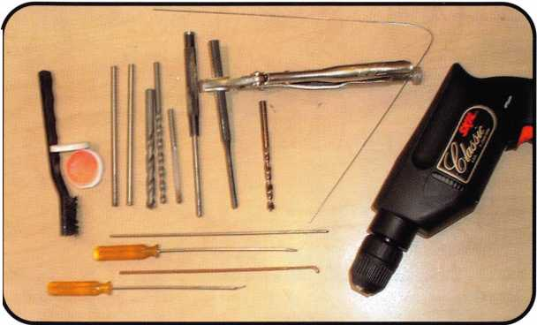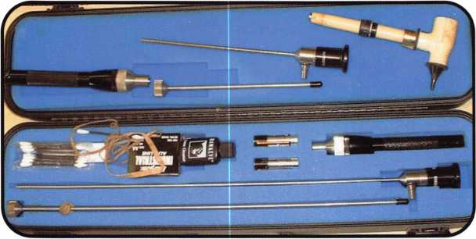

A Hawkeye scope and an otoscope are shown here. Rubber bands are used on the scope to  
mark depth on the tube. This tool is especially handy when scoping a change key hole.

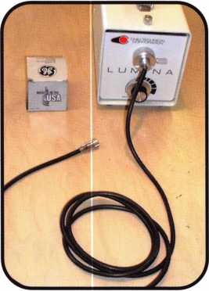

Shown is a light source with spare bulb. The fiber optic cable is sold separately.

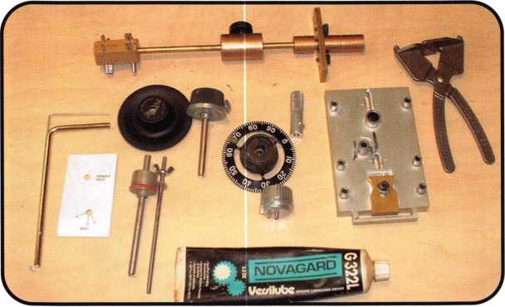

In the center are some emergency dials including one made to attach to the spindle stub after pulling a dial. GE versilube (shown on the bottom) is the preferred lube for most safe locks. Tools for MasHamilton are shown on the sides. On the left side is an X-08 probe. Next to it is a Castle King tool and a homemade tool used for loose drive cam screws. On the right side is a pair of pliers for the back and a drill template for the CD version which goes on a personnel door. On top is a MasHamilton X-07 dial ring alignment tool.

Joy to the World!

I’ve included a good basic selection  
of safe tools. Your initial investment  
will vary from $1,500 to $3,000  
depending on how much work and  
the type of safes you’re willing to  
tackle. At a minimum you need to  
have a drill rig, a good selection of  
carbide drill bits, a borescope with a  
light source, and change keys. The  
little bit more advanced technician  
should consider adding diamond core  
drills, ball buster bits, a good welder,  
longer and/or larger carbide drill bits,  
and more templates for the MiniRig  
(if that’s the rig you choose to own).  
Those who choose to open lever  
locks will need a nose puller and  
perhaps picks from Lock Defeat  
Technology. I’m sure there are many  
other great tools that will be added  
to your collection as it grows, but  
this list should give you a good start.

If you want to get more information  
on tools, contact companies like  
StrongArm at (800) 710-8168,  
Lockmasters at (800) 654-0637,  
Northwest Safe and  
Vault at (877) 241-6978,

MBA at (800) 585-4471, or  
TimeMasters at (785) 232-8705. Q

Keynotes

Just a Few

|  |  |  |  |  |
| --- | --- | --- | --- | --- |
| of the | Many Titles Available. | | |  |
| PRP Resource Guide |  | $25.00  $55.00 | Safe Deposit Depth and  Space Manual | $120.00 |
| Fundamentals of Master Keying | |
| Simplex Unican |  | $39.00 | Safe Deposit adapter kit for use with the Safe Deposit Depth and Space Manual |  |
| Manipulation Manual |  | and the HPC 1 200CM | .$85.00 |
| Locksmithing: |  | $27.00 | Safe Technicians |  |
| From Apprentice to Master |  | Reference Manual | $156.00 |
| Logical Lock Diagnostics |  | $29.95 | How to Pick Lever Locks | .$19.95 |

**Visit our Website or call to place your order today!**

[www.aloa.org](http://www.aloa.org) • (214)827-1701 x 23 • (800)532-2562 x 23

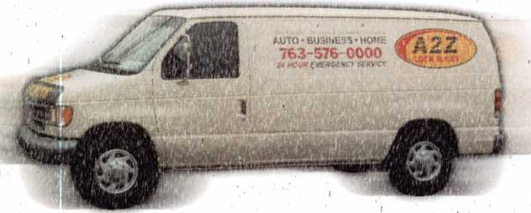

**in Middle Minnesota**

By Cory Schmidt

My day started out early on a cold December day. A lady called and said she was locked out of her car and would probably need a key made. I put on warm clothes and headed out, like a good little locksmith.

The night before, it had snowed a good eight inches or more, so I knew the trip would be interesting enough. My van did a good job, though, and with a litple swerving and a few fishtails, I wound up in front of a house that looked almost ghostly white. Nothing had been plowed, the driveway, the sidewalk, I mean nothing. This is normally not a problem, but we’re talking about rural Minnesota (think Fargo), and the driveway must have been a quarter-mile long. I zipped up my jacket, grabbed my lockout tool for the 1993 Geo Metro this lady claimed to have, and headed up to the house.

I knocked on the door, and a nice old lady answered the door. I asked her where the car was, and she smiled eerily and told me it was over beside the garage. I thanked her and marched though about another 100 yards of/eight-inch

Keynotes



snow until I got to the garage. But there was just one little problem: I couldn’t see any Geo Metro anywhere.

I looked a little harder as I walked right up to the garage now, and I started to see, almost in slow motion, that there was the roof of a car visible next to a huge pile of snow next to the garage. And that was it! To my amaze­ment, the car was buried up to the roof in a snow drift!

I wondered where she thought she was going to go once I got unlocked the car for her.

I walked drearily back to the house and did what I had to do, as a good little locksmith.

“Excuse me, miss, sorry to bother you again, but your car is buried in snow. Do you have a shovel?”

“Oh dear,” she said, her whole face a mystery. “Yes, of course, there’s one in the garage.”

“Thanks; thank you.”

I waded through more snow at the front of the garage, got inside and found the shovel. Then I went back out­side and began. It didn’t take very long, but I was laugh­ing out loud trying to shovel enough snow away to get the door exposed enough so I could work on it. I opened the car fine, but inside I found no keys. Anywhere.

I looked all over that Metro, in the ignition, under mats, in the ashtray, and there wasn’t a shiny piece of metal anywhere in the thing. And I was starting to freeze.

I went back to the house and inquired about our lost key situation.

“Oh, I have my key here.” She produced half a key for me and smiled.

“Where’s the rest?”

“It’s in the ignition.”

Back at the car, I looked into the ignition with my flash­light, and sure enough, I could see a little piece deep inside the ignition. So back to the van I went, to load up my jacket with the key blanks I would need, my pak-a- punch, vise grips, screwdriver, and yes, spiral key extrac­tors. Base camp at the car wasn’t too far away; all the trips I’d made were giving me a pretty nice little trail in the snow by this time.

I took the lady’s half of the key and put it in the ignition. Then I took two long spiral extractors and put one on each side of the key pieces in the groove. I turned them as far as they would go. Then I took the vise grips and clamped it together. Now I had it. It was as if the key was welded back together. I took the head of the screw­driver between the vise grip and the steering column and pried out the broken key. I read the key from both halfs 1 while my teeth chattered away. I cut a new key with the most sure hands I could muster, considering the shaking.

I tried the new key in the door and hf the ignition, and ! praise the saints, it worked.

My shivering hands had cut the key in one try. It had worked! The job was over. I felt a big weight lifting off my shoulders, like Christmas morning had already arrived.

I gave her the key and she paid me. And as I swerved away in the deep snow, I realized I hadn’t found out why on this snowy-white earth she needed to get in her car right away after an eight-inch snow.

But then again, I was just doing my job.

And then some.

Happy Holidays from A2Z Lock and Key in Champlin, MN Q

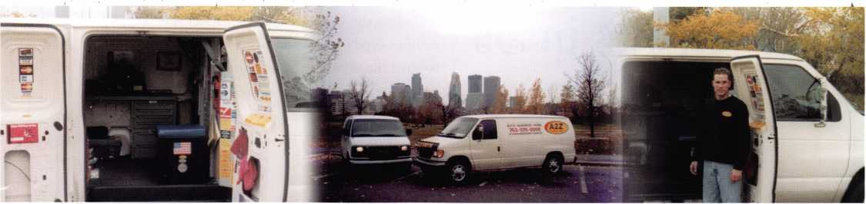

Keynotes

2

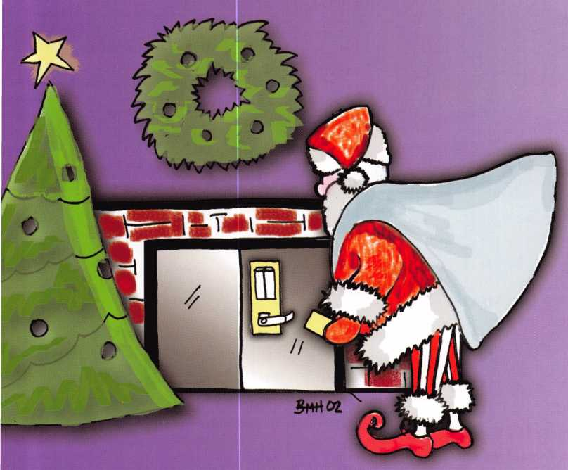

flceess

Control

HID’s Electric

Expansion:

eProx Lock

Program Grows in 3s

Since the access control revolution not too many years ago, leading lock manufacturers have been trying to cook up new ways to integrate new electronic technology into security systems. In the case of HID, three partners — Fort Lock, IR/Schlage and Recognition Source — have been inserting HID’s eProx technology into their electronic locking devices and systems.

CompX Security Products/

Fort Lock

CompX manufactures a variety of specialty lock products including the CompX eLock product line. Intended for cabinet-type applications, they have been initially targeted toward the server enclosure market. These locks provide end users controlled access to individual server racks or cabinets, in addition to protecting the main server room door. Here’s a quick breakdown:



Keynotes

Installation Issues

First, the user must know the panel cutout for the surface mount unit, and the space parameters required by the locking  
latch. Next, users need to determine the power source - batteries or power supply. The room must be allocated for the  
battery pack (if so equipped), and finally, users must locate the locking latch in a position where it functions properly and  
secures the cabinet.

Service Issues

The eLock has a life cycle of 7 years or 100,000 cycles. The latch mechanism requires no regular maintenance. It is pri-  
marily sold at the OEM level, but is available to the after-market alarm and locking hardware contractors through distri-  
bution channels. The unit requires general database maintenance and battery replacement on a yearly basis (if so  
equipped)

Applications

The CompX eLock can be used in a variety of applications including: metal enclosures, computer racks, file cabinets, and  
general cabinetry.

Bottom line: “No unauthorized entries — period.”

IR/Schlage

IR/Schlage now offers a series of computer-managed locks with “Locknetics on Board” technology. These products are  
sold under Schlage, Von Duprin and Locknetics brands. The hardware is available in cylindrical, mortise, or exit configu-

rations, multiple finishes and lever designs.

Installation Issues

The format of HID prox card/fob system is already in place in these products.

If you’re retrofitting the job, the new type of lock preparation is already on the  
door. Also, if you’re retrofitting, consider finishing existing hardware on the  
door or around the facility. Think about frequency of use, indoor/outdoor use,  
and level of security needed

Service

Service calls are needed about every two to three years until the batteries need  
to be changed, depending on frequency of use. The people who install these  
locks vary from locksmiths to hardware contractors and other security system  
integrators. To compare these products with an on-line card reader, keep in  
mind that it acts as a complement to on-line readers, providing electronic  
access control to access points that may be difficult to get power or network  
wiring to. The applications for these products vary, with many solid institu-  
tional applications for colleges and universities (residence hall rooms, common  
areas, classrooms, laboratories, administrative offices), K-12 Schools (class-  
rooms, administrative offices, etc.) and hospitals (patient rooms, record rooms,  
pharmaceutical cabinets).

One particular feature of these products that is really nice is the ability to read multiple credentials and offer linked access  
(credential + PIN) for higher security applications. It’s also available in perimeter exit device trim to have the ability to  
cover and manage multiple types of access points.

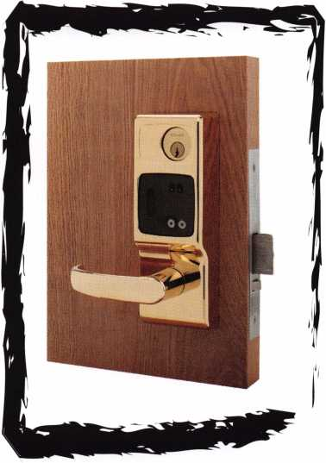

Keynotes

Bottom Line: “Our experience with prox locks is that they are the most reliable and offer the highest security. The readers are not exposed and therefore can’t be damaged by vandalism or weather.”

Recognition Source

Recognition Source’s Wyreless Access product operates at 900 mHz spread spectrum and is a wireless on-line door access sys­tem. The system is compatible with HID proximity credentials and is perfect for those hard-to-wire installations. The wireless door hardware communicates to a controller up to 200’ indoors and over 1000’ outdoors.

Installation Issues

There are a couple considerations regarding the technical issues to be aware of when installing your eProx lock. First, it’s installed as part of Recognition Source’s Integrated Reader Lock for online systems. Also, it installs in 1 hour for full access con­trol “online” at the door - a nice feature.

Service Issues

You may be wondering what types of companies install these locks — alarm or locking hardware contractors? Simplicity broadens the spectrum, because lock hardware dealers, access control OEM’s and end users all do installations. It’s so simple that anyone can install it.

Compared to online card readers, these products offer similar but different options. Recognition Source made HID’s products into an online card reader with an RF connection to the panel.

So it’s just as fast as a regular card reader, but with a shorter read range. Customers are willing to have shorter read range in order to handle the hard-to-wire applications with an online solution.

Bottom Line: “The combination of HID’s industry leading prox­imity technology and our revolutionary Wyreless Access wire- free communications provides a powerful solution for those hard-to-wire installations. It offers a very unique low-power proximity reader solution that is perfect for our battery-powered requirements without sacrificing the benefits of an online solu­tion. We are also using it as a hand- held portable reader in com­bination with our RF to the access panel, another unique appli­cation.”

For more on eProx or to view these new partners and their respective web links, visit HID’s website at [www.hidcorp.com](http://www.hidcorp.com). Q

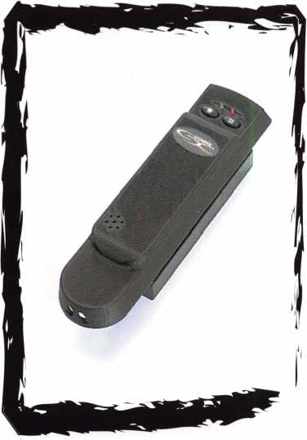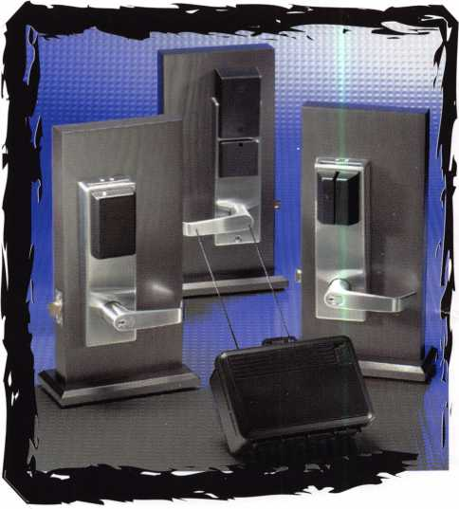

Keynotes



**April 8-13**

**John Ascuaga’s Nugget Resort • Reno, Nevada**

r e n o , nevada



2^2

Jjjiiirijci'jijijl Lyr&JjjJJijJJjJ!)

By Dave Hasty, CRL

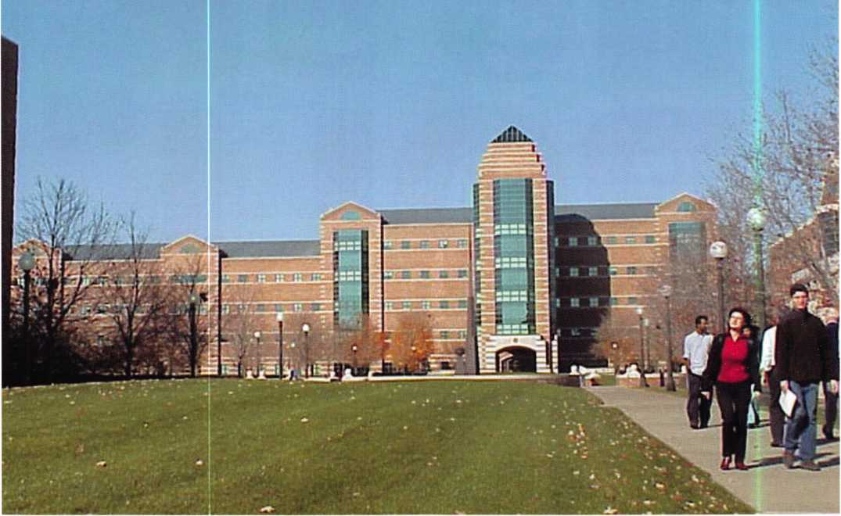

I’ll admit that the articles on Institutional Locksmith

issues that have been featured in Keynotes this year have caught my eye, and  
I have enjoyed reading them and pondering the similarities to my position

as foreman of the Locksmith Shop at the University of Illinois at Urbana Champaign. I can particularly

relate to C.D. Lipscomb’s article in the May issue as he summed up so many issues quite well.

Keynotes

With that being said, I will try and shed some light on the operations here at the University of Illinois. Here at UIUC, our workload is basi­cally broken down into four categories, and they are as follows:

1. Key Inventory. This is our term for the position of our shop person. The duties of this position include the inventory of keys belonging to all of the departments on campus, and filling all key requests for the campus. We cut approx. 60,000 keys per year, from door keys to desk keys and automotive keys. We cut keys for 6 major manufacturers cov­ering roughly 180 different keyways, just for building doors.
2. Departmental. This consists of work orders placed by and paid for by departments on campus (our customers). These services include lock changes, safe combination changes, lock repair for office furniture, specialty locks, etc.
3. Projects. These orders are generally for specific work, such as keying a remodel job or new construction. We also specify hardware for all remodel and new construction jobs.
4. Repair/maintenance. This is the big one; this covers approximately 75 percent of our workload. This involves the repair and maintenance of the locks here on campus, with the exception of student housing, which is handled by their own personnel. This may come as a surprise to most institutional locksmiths at universities, but given the size of our campus and the duties of our shop, we stay plenty busy.

Our campus consists of 756 buildings totaling approximately 18 million square feet of space. Of these, 268 are what we consider “major,” in that they are 10,000 square feet or larger.

Our campus houses a supercomputer that many of you may have heard about, as well as one of the largest libraries in the country. We are also a very old university. Our oldest building on campus is Mumford House built in 1870; our oldest major building is Harker Hall built in 1878, but these buildings have been remodeled. The oldest building fully utilizing the original hardware was built in 1908 utilizing Best mortise locks.

Mortise locks are specified in building standards but we do have a few buildings that have grade 1 cylindrical locks, as well some with Yale and Corbin unit locks. The majority of panic bars are Von-Duprin, with most door closers being LCN or Norton. We also rebuild our door closers, utilizing a shop specifically for this. We are also responsible for the card access locks on campus, which consist of Best V-Series as well as the new Schlage CM locks with Locknetics on board, as well as Andover Controls for our hardwire systems.

All of this lock work is done with eight full-time locksmiths in our shop, with a combined 201 years of locksmith experience, 152 of those years spent here at UIUC. Four of our locksmiths have spent their

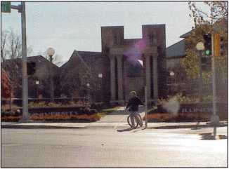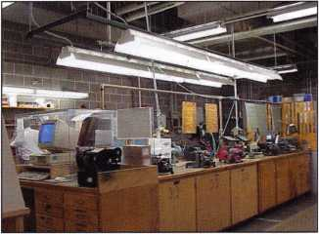

Keynotes

MasterLink Security Products

ROGER ALEXANDER-TUTTLE

“...understanding the needs of locksmiths...”

Mortise/Rim/Knob Cylinders • Storefront Door Hardware  
Cabinet Locks • Chain • Key Blanks • Padlocks • Pins ...and more

Local: (954) 730.9669 • Toll Free: (877) 347.9669  
Fax: (954) 486.0575

e-mail: [masterlink@mindspring.com](mailto:masterlink@mindspring.com)

3863 NW 19th Street, Lauderdale Lakes, FL 33311

It's True

Marray has developed the first  
screwless door loop.

Aluminum ma­terial means true anodizing.

No off color powder coat­ing or painting

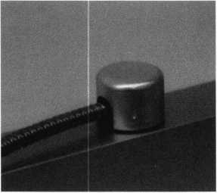

Standard 18”  
length. Can be  
ordered in cus-  
tom lengths

Plastic base stops  
shorts and pro-  
tects wires

Screwless base and cap means you drill two 1/2 inch  
diameter holes, pop the base into the hole, wire your  
system and snap on your covers. Simple as 1,2, 3.

**Here’s the best part We are giving away a**

FREE SAMPLE TO THE FIRST **1 OO** CALLERS WHO MEN-  
TION THIS ADD. **A $14.40** WHOLESALE PRICE VALUE.

CALL TODAY, IT’S FREE!!

1-800-500-1449

**Marray *enterprises, inc.***

At **Marray,** we’re not just modifiers, we’re Master Hardware Modifiers™  
**1128** Walsh Ave., Santa Clara, CA **95050**. **[www.marray.com](http://www.marray.com)**

careers here, while the other four (myself included) started in commercial shops. We work for the Operations and Maintenance division, which houses prac­tically every trade there is. We are a union shop, with the locksmiths belong­ing to the International Association Of Machinists and Aerospace Workers local 431. I have not seen this mentioned before and don’t know how many lock­smiths out there belong to a union. Being unioniz fo does bring up a few issues, in that we have pretty specific guidelines and boundaries in our job descriptions as to what work can be done by a given craftsman. It does, however, give us access to some of the best craft people in the trades when we need their services.

One thing I would like to stress is the repair and maintenance of the locks with­in our campus. While I fully understand the importance of key control, and stay­ing on the cutting edge of card access, we must never forget the function of the lock itself. Even if we can account for every restricted key for every high securi­ty cylinder on campus, we aren’t covering all of our bases from a security stand­point. Mechanical locks still are a huge part of total physical security. If the pick proof on the mechanical lock is faulty, or the latch is binding in the strike, or the outside doors don’t latch because some­one has stuck a penny in the panic bar, or the door closer is out of adjustment allowing the door to “hang,” how much security do we really have?

As complicated as our field has become and as important as it is to keep up with current technologies, we must never overlook the obvious. Simply, as Merriam-Webster puts it: “lock.smith — one who makes or repairs locks.”

That’s all for now from the land of the Fighting Illini, but if anyone would like to contact me, just drop me an e-mail: [dmhasty@uiuc.edu](mailto:dmhasty@uiuc.edu). Q

Keynotes

)

Joseph C. Fuller CML, CMST 13

Leonard J. Passarello CPL 13

Frank D. Hartung CML 13

Rolando Bouza 1 3

Paul M. Souber 1 3

Donald H. Shiles RL 13

John A. Ilk CRL, CPS 13

Richard C. Sievers 13

Ernest W. Wright 12

Raymond C. Lusk CML 12

John F. Engel CRL 12

Eric F. Veal 12

Thomas J. Demont CML, AHC 1 1

Basil W. Shannon CPL 1 1

Calvin G. Harris CML 1 1

Herbert C.

Dusenberry CML, CPS 1 1

Timothy K. Chow 1 1

Dale L. Knowles CPL 1 1

Alvin N. Minor 1 0

Gene Eldridge CPL 10

Ronald P. Riggins CML 10

Lester S. Brodsky 10

Larry L. Votaw CML 10

Thomas R. Smith CPL 10

Todd K. Ladwig CML 10

William T. Straub CML 10

Richard T. Johnson CPL 10

Dale V. Crosby CPL 10

James V. Hawley CRL 10

Eugene R. Altobella Jr 10

James Bright 10

How can I join the  
President's Club?

You can earn a membership in this  
prestigious club by recruiting just  
10 new members for ALOA.

*Any ALOA member may participate.

What do I get?

When you recruit 10 members, you  
receive this sharp, royal ring, or  
a handsome blue blazer with a  
President's Club crest. For each  
additional five members you recruit,  
you receive a lapel pin with gold-  
filled numbers, indicating, your  
recruiting successes.

You also get the satisifaction of  
knowing that you are helping your  
association, helping your industry  
grow, and you are helping fellow  
locksmiths achieve success.

How do I get started?

Contact the ALOA office for a sup-  
ply of applications (800) 532-ALOA  
or FAX (214) 827-1810. One  
President's Club credit is awarded  
for each new applicant. Credit is  
awarded only after the membership  
application is pproved. However,  
the credit will apply for the period  
in which the application is  
received. Failure to identify yourself  
as the sponsor on the application  
form at the time it is submitted  
to ALOA for processing will  
forfeit any credit.

Keynotes

Member Name Number

of

Sponships

Kwok-kei Leung 204

Toshihiro Asa no 1 13

Henry W. Raymond 100

Yuriko Yanai 69

Stewart J. Levine CML 66

Mary S. Ohmit CPL 66

Charles C. Robertson CML 65

Jack Hobin CPL 51

Salvatore J. Dulcamaro CML 40

Myeong-Rae Cho 38

Dana L. Barnum CML 35

Barry K. Leas CRL 35

C. Allan Halverson 34

Danny W. Rudd CPL 31

Larry A. Warnick CML 31

Jeanne G. Lodge CML 30

Breck H. Camp CML 28

William Lee 28

Lawrence F. Smith Jr, CML 27

James M. Watt CML, CPS 27

Jim Williams CRL 27

Anthony J. Ramunno CML, CPS 26 Marian M. Swann CRL 26

Jeffrey S. Nunberg CML, CMS 26

J Thomas Hood CML 26

John C. Elliott Jr, CML, CPS 25

James H. Glazier Sr, CML 25

Robert F. Carroll CPL 25

Robert H. Stafford CML 25

Robert D. DeWeese CML 24

Jerome L. Cohen CML 23

Peter K. Gauthier CPL, CPS 23

Elvis D. Hammerschmidt CPL 23

Man-Soo Seo 23

Michael B. Groves 23

Diana R. Barnum CRL 22

James J. Cawby CML, CPS 21

Philip A. Rovenolt CPL 21

Eugene R. Altobella S 21

John L. Shandy CML 1 9

John S. Dorsey CM 19

D. Michael Lee Sr, CPL 19

Robert W. Duman Sr, CML 19

Keizo Takahashi CRL 1 8

James E. Fowler Sr, CML 1 8

David C. Harris CML 1 8

Walter W. Lascar R 17

Peter R. Hall 17

Thomas G.

Vandersteen CML, CPS 17

William P. Grant CRL 17

Evelyn V. Wersonick CML, CPS 16 Joseph P. Ferrero CML 16

Gary F. Teams CPL 16

Kenneth E. Kim CRL 16

Michael E. Jordan Jr, CML 16

Brian J. Reetz 16

Robert C. Rodocker CRL 15

William J. McElheney CML 15

Joseph W. Whitaker CPL 15

Jon B. Griswold CML 15

Michael D. Robinson CRL 15

Russell P. Fuller CRL 15

Daniel L. Landry Jr 15

James L. Hancock CRL 15

James E. Gruber CRL 14

James T. Brickler CRL 14

*ALOA Board of Directors not eligible for membership in the President's Club



We need a lock rekeyed NOW!

But where’s the lock?

We all get the call, a customer must  
have a lock or group of locks rekeyed  
and they can’t wait. They want it done  
now. We recently received one of  
those calls from a purchasing agent.

I pushed a couple of other calls aside  
and headed out for the hour drive to  
the customers. I got there and met  
with the secretary I asked which lock  
she needed rekeyed. She pointed to a  
beautiful solid core oak pocket door  
without a lock. I asked about the  
rekey and she said there was a little  
misunderstanding. Seems they really  
needed a lock installed. OOPS, my  
rekey became a lock install. Time for

some regrouping. I looked in my truck and decided an Adams  
Rite MS1851 hook bolt lock would work but installation  
would be kind of a problem. This lock is designed to go on  
an aluminum glass door. It is used often on sliding automatic

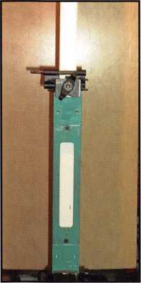

This is the HIT-45 modular clamp  
attached to the door. The Adams  
Rite face plate router guide is  
installed.

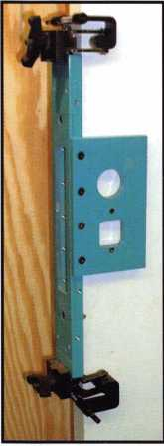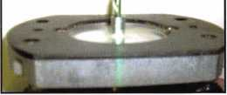

I’ve now added the tem­plate for the cylinder hole and indicator. Only cut the indicater hole on the inside of the door. These templates come in differ­ent backsets 31/32”, 1, 1/2” and 1 1/8”.

storefront doors, but would it work  
on my wood door? And how would  
I install it, I don’t own a mortising jig,  
or do I? Since this customer has a no  
camera policy I found an old door to  
repeat this process in my garage. I also  
used some plywood as a backdrop for  
better picture quality.

I started off using a Major Mfg. HIT-45  
modular clamp installation jig with the  
face plate router guide normally used for  
aluminum glass doors. I measured the  
thickness of the faceplate and mounting  
tabs and set this depth on my plunge  
router. I routed the mortise pocket on

the edge of

the door.

Next I  
added the

template to the side of the  
clamp and used the router  
guide to create the cylinder  
hole. I then transferred the

A router guide is added to the router base.  
Major Mfg. stocks them for Porter Cable or  
you may order them from most tool supplies.

Keynotes

|  |  |
| --- | --- |
|  | § |
|  | w |
|  |  |
|  |  |
|  |  |
|  |  |
|  |  |
|  |  |

The door has been routed and the  
HIT-45 clamp removed.

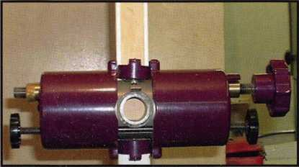

I’ve now added the HIT-44 to the door. This will be used to bore the  
mortise pocket. You can see the mark I made at the top of the  
faceplate pocket. I’ve lined the tool up to start the bottom cut just  
at the lower mark.

template to the opposite side of the  
clamp and routed the hole on the  
other side of the door. I removed the  
clamp assembly. I now have a face-  
plate pocket and cylinder holes but  
how do I create the mortise pocket?  
Out comes another Major Mfg. tool.  
This time I used the HIT-44 which  
is normally used for installing cylin-  
drical locks. I marked the top and  
bottom of the mortise pocket and  
set the HIT-44 bottom of 1” cross-  
bore to the lower mark on the door.

I marked the depth on the drill bit  
with a piece of tape and drilled the  
hole. Next I moved the jig up about

3/4” and  
drilled this  
hole. I contin-  
ued this  
process until  
the pocket  
was cut to the  
top mark. A  
chisel was used  
to clean the  
sides of the

almost perfectly.

I say almost because  
the door would open  
about 1/2” when  
locked, a little more  
then I liked, but the  
customer was quite  
happy. This lock was  
needed to prevent  
prying eyes not for  
high security. If  
higher security was  
needed Adams Rite  
makes an armored  
strike which could  
be attached to the  
2x4 frame inside  
the wall.

Edge picture of the  
lock case and outside  
cylinder hole.

The completed  
installation.

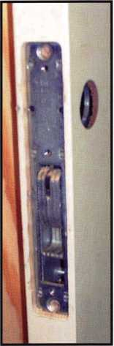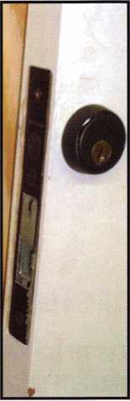

I would use this method to install a full size mortise lock. The only difference is using the appropriate template for the mor­tise lock being installed. This clamp assembly and templates work great on pre-mortised hollow metal or wood doors. I’ve also used them on doors when changing to a different brand of lock. The HIT tools are designed to help locksmiths, and they certainly did their job this time. They have proved to be one of the better investments we as a company have made. Q

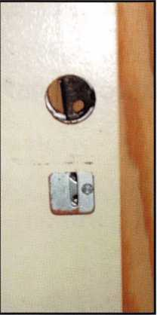

hole and square both the top and

bottom of the mortise pocket. After

installing the lock in this pocket and

installing the cylinders I extended

the bolt and transferred to the frame

the posi­

tion need­

ed for the

strike. I

used the

router to

cut the

hole and

tested the

This is the result of cutting a series  
of holes up the door edge. The two  
HIT tools center perfectly on the  
door. This door is a hollow core but  
it works the same on a solid core  
door. A wood chisel was used to  
clean the sides.

lock. A few modi­fications

were

made to the hole, the lock worked

Inside shot with the lock installed.

TOOLS

This is HIT-45 clamp off the  
door with a couple of the  
mortise lock templates, Yale  
on the left and Schlage on  
the right.

Here are the full size mortise  
lock router guide and an  
adapter plate to center the  
clamp on a pre-mortised  
wood or a hollow metal door.

This little tool is a HIT-  
22 mortise cylinder drill  
guide used to get a  
perfect alignment of  
the mortise cylinder  
hole if you don’t want  
to set up the HIT-44 or  
don’t own one. Simply  
insert the the round  
plug into the mortise  
cylinder hole of the  
lock. Drill a 1/2” hole in  
the approximate center  
and install the lock in  
the mortise pocket.  
Use the 1/4 rod at the  
top of the photo  
instead of a drill bit in  
your 1 1/4” hole saw  
and it guides the hole  
saw through the face of  
the door. It can also  
be used to clean up a  
poorly drilled hole.

Here are a flush bolt guide  
on the bottom and an  
ASA strike router guide to j  
complete the installation.

This is the HIT-44 in it’s I case. I also carry 7/8”, 1”, I 1 1/2” and a 2 1/8” hole for I hollow metal doors or in I case I need to enlarge an 1 existing hole.

Keynotes

**3**

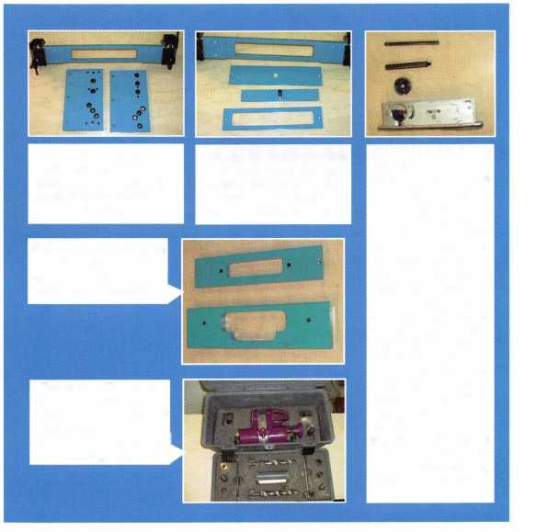

LEGISLATIVE WRAP-UP

LISTING OF BILLS ALOA TRACKED DUR­ING THE 2001 LEGISLATIVE SESSION

ALOA worked very hard this year on legislation affecting the security industry We tracked over 19 bills in 12 states that had a direct impact on our members and all locksmiths. Here are the highlights:

CALIFORNIA AB143

Requires locksmiths to maintain a bond of $2,500 for the benefit of persons damaged by a locksmith's failure to comply with the afore­mentioned duties and restrictions.

STATUS: 02/16/2001 To Assembly Committee on Business and Professions.

CALIFORNIA SB722

Increases fees and fines for violations of the Private Security Services Act by locksmiths, private investigators, private security services, pri­vate patrol operators and alarm companies. Imposes fines on private patrol operators for violation of certain operating requirements.

Deletes provisions regarding agency regulation of fees and fines. Relates to the required arrest training courses required to persons entering into the security services arena.

STATUS: 10/07/2001 Signed by Governor.

CONNECTICUT SB 1323

Concerns telecommunications infrastructure layout technicians and the registration of employees of telecommunications providers; establishes licensing programs for telecommunications infrastructure layout techni­cians. ALOA was instrumental through working with BICSI in getting Home Improvement Contractors (which locksmiths fall under) written out of this act.

STATUS: 07/06/2001 Signed by Governor.

ILLINOIS HB26

Provides that giving notice to the public by yellow page advertise­ment, through a sign at the facilities of the towing service, or by any other advertisement, that the towing service opens motor vehicle locks to enable a vehicle to be moved without towing does not constitute holding oneself out to the public as a locksmith if the advertisement does not use the word "locksmith"

STATUS: 03/27/2001 Tabled by Sponsor.

ILLINOIS HB2219

As introduced, changed definition of burglar alarm system to include CCTV. NOW, only makes a technical change for restoration of a license after disciplinary proceedings

STATUS: 04/06/2001 Re-referred to House Committee on Rules

ILLINOIS HB2536

As introduced, allowed for electronic fingerprints. NOW, makes a technical change concerning the temporary suspension of a license

STATUS: 04/06/2001 Re-referred to House Committee on Rules

ILLINOIS SB115

Amends the Illinois Vehicle Code; provides that other than at the time of sale of the vehicle, no vehicle dealer may issue to any person a new key to a vehicle unless the person can prove that he or she is the owner of that vehicle by the certificate of title or the vehicle registration card

STATUS: 08/16/2001 Signed by Governor.

ILLINOIS SB967

Provides for regulation of electricians and electrical contractors; provides that performing unlicensed electrical work, when a license is required by this Act, constitutes a business offense for the first violation and a Class A misdemeanor for a second or subsequent violation; provides for concurrent exercise by home rule units

STATUS: 03/31/2001 Re-referred to Senate Committee on Rules.

**38**

Keynotes

INDIANA HB1545

Requires employers to disclose to an employee or prospective employ­ee any type of electronic monitoring of employees Limits the extent to which an employer may electronically monitor their employees

STATUS: 07/26/2001 Session Adjourned. No Carryover.

MARYLAND HB224

Authorizes the Secretary of State Police to adopt regulations to establish fines for specified violations; requires specified individuals to be licensed as private detectives, security guards, or security systems technicians by the Secretary of the State Police before soliciting and engaging in business

STATUS: 05/1 8/2001 Signed by Governor.

MARYLAND HB1368

Tightens the definition of Security System to include locks, electronic access control, alarm and closed circuit television.

STATUS: 03/26/2001 Reported unfavorably out of committee.

No further action.

MISSISSIPPI HB148

Regulates and licenses the installation and servicing of burglar and intrusion alarm systems

STATUS: 02/27/2001 Died in Committee.

NEW YORK AB3971

Establishes security requirements to be fulfilled by owners of multiple dwelling units including deadbolt locks, window pins, adequate light­ing, solid core doors, intercoms and optical viewers; provides require­ments for each such security measure.

STATUS: 02/05/2001 To Assembly Committee on Housing

NORTH CAROLINA HB942

Establishes the locksmith licensing act.

STATUS: 08/15/2001 SIGNED by Governor.

SOUTH CAROLINA SB381

Relates to the registration of locksmiths

STATUS: 02/27/2001 To Senate Committee on Labor,

Commerce and Industry

OREGON HB2563

Creates Class A violation of unauthorized duplication of keys marked "Do Not Duplicate"

STATUS: 01/25/2001 Sent to House Judiciary Committee

TEXAS HB1077

Relates to the registration of locksmiths

STATUS: 07/25/2001 Session Adjourned. No Carryover.

TEXAS SB 1224

Changes definition of alarm system to include all access control. STATUS: 06/17/2001 Vetoed by the Governor.

UTAH HB222

Modifies the Individual Income Tax Act to create a refundable individual income tax credit for the purchase of a residential security container

STATUS: 06/15/2001 Session Adjourned. No Carryover.

El

Keynotes

**3**



EMPLOYMENT

EXPERIENCED LOCKSMITH WANTED

Live, work, and enjoy Florida's east coast in beautiful

Brevard, Co. Must be able to run after hour calls.

Top salary and or commission.

Call T-888-752-7233.

WANTED: EXPERIENCED TECHNICIANS Lock into your future now! If you are an experienced, intelligent technician, and desire a secure future, come join our team. We are a full service commercial/ residential security service (locks,keys,safes,access control,cctv,all door related hardware,alarm systems) We offer: large sign on bonus, top wages, company vehicle, 401k, paid vacation and holidays, health benefits, new uniforms, cross training, and JOB SATIS­FACTION. We are looking for the best tech's who are ready to be treated and compensated as professionals. Contact: Bass Security Services, INC.

Phone: 216-755-1200 xl28

Fax: 216-755-1220 • Toll free: 800-523-1422

e-mail: [rmesnick@bass-security.com](mailto:rmesnick@bass-security.com)

WANTED: SALES SUPERSTAR

Here we grow again! Bass Security Services, Inc. is look­ing for the best of the best. If you are an experienced, motivated, and no-nonsense sales professional with an extensive background in the security industry, we want YOU! All candidates must have a minimum of 5 years in the locksmith / security field, with a background in sales and customer service. We offer: Top wages with excel­lent incentives , 401k, paid vacation and holidays, health benefits, and continued industry education. Re-location assistance may be provided.

Contact: Bass Security Services, Inc.

Phone: 216-755-1200 xl28

Fax: 216-755-1220 • Toll free: 800-523-1422

e-mail: [rmesnick@bass-security.com](mailto:rmesnick@bass-security.com)

WANTED TO BUY

We are in need of a discontinued unit lock made by Corbin Lock Inc. The old series number was 966-35lx C26D. If you can assist us in locating, new or used locks it would be greatly appreciated.

Craig Smith, Facilities Management

2500 University Drive N.W. ST 068

Calgary, Alberta T2N 1 N4 Canada

Business: (403) 220-3680 • Mobile: (403) 512-9536

Fax: (403) 210-8142 • e-mail: [csmi@ucalgary.ca](mailto:csmi@ucalgary.ca)

Classified Advertising Policy

Classified advertising space is provided free of charge to ALOA members, and for a fee of $.60 per word, $ 15 minimum for non-members. Classified ads may be used to  
advertise used merchandise and overstocked items for sale, "wanted to buy" items, business opportunities, employment opportunities/positions wanted and the like. Mem-  
bers or non-members wishing to advertise services or new merchandise for sale may purchase a "Commercial Classified Ad," for a fee of $1.30 per wordI, with a mini-  
mum of $40. Each ad will run for two issues. For blind boxes there is a $5 charge to members and non-members. All ads must be submitted in writing to the ALOA office  
by the fifteenth of the month, two months prior to issue date. Send to Keynotes Classifieds, 3003 Live Oak St., Dallas TX 75204-6186. ALOA reserves the right to refuse  
any classified advertisement that it deems inappropriate according to the stated purpose of the classified advertising section.

4

Keynotes



BUSINESS FOR SALE

ESTABLISHED LOCKSMITH AND SECURITY BUSINESS FOR SALE

Are you looking for a great business opportunity, sinchine, clean air and a great community for raising a family? We've got it! Building, businesses and rental property are all included. Business is located in south central Colorado in a growing community. Call PORTER REALTY for more information! 719/589-5899.

FOR SALE

Tampa Florida's -oremost mobile locksmith service. Established 1982. Sale includes merchandise, assets, 1996 service van and customer list. Contact Richard at [Towerkey3@aol.com](mailto:Towerkey3@aol.com), or call 813/985-2028.

ESTABLISHED LOCKSMITH AND SECURITY BUSINESS FOR SALE Are you looking for a great business opportunity, sunshine, clean air and a great community for raising a family? We've got it! Building, businesses and rental property are all included. Business is located in south central Colorado in a growing community. Call Porter Realty for more information, 719/589-5899.

FOR SALE

Established locksmith business for sale in Pembroke Pine, FL. Same location since 1972. The store comes with equipment, two vans and residential and commercial accounts. Grosses over $100K per year. Serious inquiries only. Please contact Peter at 954/962-4535.

WANTED TO BUY/SELL

FOR SALE

100-ACE Realtor, over the door lock boxes. All keyed alike - only $3 each. Call, Key Hole at 806/352-2157. Weekdays only, 8:30 a.m. to 5:30 p.m.

FOR SALE

LeFebure Safe Deposit Locks 7700 and 7750, nickel and brass-plat­ed. Keyways are flat/flat, with double small noses. $38, each with renter keys. Some other safe deposit locks are also available:

Mosler, S&G, llco Unican, HHM. Call toll free 888/245-6870.

FOR SALE

Ilco/Orion KD56 C/E High Security Winder Key Machine. Also cuts KESO keys. $600 plus shipping and handling. Call John at 203/397-3093, or e-mail to [amitylock@snet.net](mailto:amitylock@snet.net).

Locksmith Training

6-Day Program • Career Change in One Week • January 21-26, 2002

This is a basic locksmithing training course sponsored by FVTC’s Security and Crime Prevention  
Department and conducted by ALOA ACE instructors. Designed for the locksmith shop owner  
who would like to provide entry-level training for new apprentice locksmiths as well as those who

would like to receive professional training that will enable employment with a professional locksmith. The course will allow the student  
to gain enough knowledge to make them a starting apprentice in an existing shop. Job placement locations will be made available at the  
time of the class.

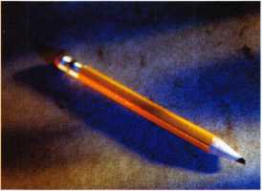

To maintain quality the course enrollment will be capped at 12 students. Enroll early!

Curriculum includes:

Key Blank Identification and Duplication Lockset Servicing, Functions, Finishes

Key Codes and Code Equipment Life Safety Codes

Basic Master Keying Lock Pick Opening Techniques

All tools and equipment will be made available for use during training.

Class Flours: 8:30 am to 5:00 pm every day Class Attire: Shop clothes Course Tuition: $995.00

Pin and Disc Cylinder Servicing Door Closers

Key Impressioning Lockset |nsta||atjon

Lock By-Pass Techniques Cabinet, Furniturei Mai|box Locks

Exit FJardware

Course Enrollment: See Linda Buck in the Criminal Justice Center

or call 920-735-2406

Note: Enrollment deadline is Wednesday, January 2, 2002

Keynotes



MANUFACTURERS

A & B Safe Corp.

(800) 253-1267  
FAX (856) 863-1208

Abloy Door Security

(514) 335-9500  
FAX (514) 335-0430

Adams Rite Manufacturing Co.

(909) 632-2300 FAX (562) 699-5094

Adesco Safe Manufacturing Co.

web: [www.adesco.com](http://www.adesco.com) (800) 821-6803 FAX (562) 408-6427

Adrian Steel Company

(800) 677-2726 FAX (517) 265-5834

Alarm Lock Systems, Inc.

(800) ALA-LOCK FAX (516) 789-3383

American Lock Co.

(708) 534-2000 FAX (708) 534-0531

American Security Products (AMSEC)

(800) 423-1881 FAX (909)685-9685

Baldwin Hardware Corp.

(610) 736-4012 FAX (610) 796-4493

Buddy Products

(800) 886-8688 FAX (312) 733-8536

BWD Automotive

(334) 874-9001 FAX (334) 874-601 1

COMPX Security Products

(864) 297-6655 FAX (864) 297-9987

Curtis Industries

(800) 555-5397

Cygnus Business Media, Inc.

(770) 886-0800 FAX (770) 889-7703

DETEX Corporation

(800) 729-3839 FAX (830) 620-671 1

|  |  |  |  |
| --- | --- | --- | --- |
| fj 1 a i | > s o c  m e m b | •  i  e | a t e  r s |
| DORMA Architectural | LCN Closers (Division of |  | SARGENT Manufacturing Co. |
| Hardware | Ingersol) |  | (800) 727-5477 |
| (717) 336-3881 | (815) 875-3311 |  | FAX (888) 863-5054 |
| FAX (717) 336-3500 | FAX (815) 875-3222 |  |  |
|  |  |  | STRATTEC Security Corp. |
| Don-Jo Manufacturing, Inc. | La Gard, Inc. |  | (414) 247-3333 |
| (978) 422-3213 | (310) 325-5670 |  | FAX (414) 247-3329 |
| FAX (978) 422-3467 | FAX (310) 325-5615 |  |  |

DSC Group of Companies

(905) 760-3000 ext. 2200 FAX (905) 760-3040

Door Controls International

(800) 742-3634 FAX (800) 742-0410

ESP Lock Products, Inc.

(978) 537-6121 FAX (978) 534-9109

HES, Inc.

(623) 582-4626 FAX (623) 582-4641

Hardware Agencies, Ltd.

(416) 462-1921

Hongtai Lock Co Ltd.

.(137) 238-1414 FAX (208) 793-3856

llco Unican

(252) 446-3321 FAX (252) 446-4702

Intellikey

(800) 226-0703 FAX (407) 724-0811

Jensen Tools, Inc.

(602)453-3169 FAX (602)438-1690

Jet Hardware Mfg. Co

(718) 257-9600 FAX (718) 257-0973

KABA High Security Locks

(860) 621-3601 FAX (860) 621-9727

KEY-BAK; Div. of W. Coast Chain Mfg.

(909) 923-7800 FAX (909) 923-0024

Knaack Manufacturing Co.

(800) 456-7865 FAX (815) 459-9097

LAB Security

(800) 243-8242 FAX (203) 583-7838

Lucky Line Products

(619) 549-6699 FAX (619) 549-0949

M.A.G. Engineering & Mfg. Inc.

(714) 891-5100 FAX (714) 892-6845

MARKS USA

(516) 225-5400 FAX (516) 225-6136

MARRAY ENTERPRISES

(408) 970-0213 FAX (408) 970-8767

Master Lock Company

(414) 444-2800 FAX (414) 449-31 14

Medeco Security Locks

(540) 380-5000 FAX (540) 380-5010

Meilink Safe Company

(800) 634-5465 FAX (800) 896-6606

MMD Inc.

(602) 453-3169 FAX (602) 438-1690

MCS Communication Systems

(865) 428-3611 FAX (865) 453-4136

Massglass & Door Service

(888) 742-8837 FAX (818) 991-5742

Monaco Lock Co.

(800) 526-6094 FAX (800) 845-5625

Mul-T-Lock USA, Inc.

(800)562-3511 FAX (973)778-2029

ROFU International Corp.

(800) 255-7638 FAX (253) 922-1728

Rutherford Controls Int'l. Corp.

(757) 427-1230 FAX (757) 427-9549

Sargent & Greenleaf, Inc.

(606) 885-9411 FAX (606) 887-2057

Schlage Lock Co.

(800) 847-1864 FAX (800) 452-0663

Schwab Corporation

(765) 447-9470 FAX (765) 447-8278

Securitron Magnalock Corp.

(800) 624-5625 FAX (702) 355-5636

Security Door Controls

(805) 494-0622 FAX (800) 959-4732

Security Solutions

(405) 376-1600 FAX (405) 376-6870

Sentry Group

(716) 381-4900 FAX (716) 381-8559

Somerset Security Products

(800) 881-5206 FAX (800) 206-9949

Sully Tools Inc.

(703) 689-3416 FAX (703) 787-0869

Sun-IL Gum Go

(823) 194-59300 FAX (823) 194-59400

Taymor Industries, Inc.

(800) 388-9887 FAX (800) 288-8133

The National Locksmith

(630) 837-2044 FAX (630) 837-1210

Trine Access Technology

(718) 829-4796 FAX (718) 792-9127

Videx, Inc.

(541) 758-0521 FAX (541) 752-5285

**2**

Keynotes

**associate**

**members**

W-Lok Corporation

(616) 3554015 FAX (616) 3554295

Yale Security Inc.

(800) 438-1951 FAX (800) 338-0965

DISTRIBUTORS

Accredited Lock Supply Co.

(800) 652-2835 FAX (201) 865-5031

Ace Lock & Security Supply Co.

(800) ACE-LOCK (800) ACE-FAX4

ADI

(516) 692-1000 FAX (516) 692-3457

Andrews Wholesale Lock Supply

(717) 272-7422 FAX (717) 274-8679

Boyle & Chase Inc.

(800) 325-2530 FAX (800) 205-3500

Clark Security Products, Inc.

(800) 854-2088 FAX (619) 974-5284

Cook's Building Specialties

(505) 883-5701 FAX (505) 883-5704

Dire's Lock & Key Co.

(303) 294-0176 FAX (303) 294-0198

Direct Security Supply, Inc.

(800) 252-5757 FAX (800) 452-8600

Doyle Security Products

(800) 333-6953 FAX (612) 521-0166

Dugmore & Duncan Inc.

(888) 384-6673 FAX (888) 329-3846

E. L. Reinhardt Co., Inc.

(800) 328-1311 FAX (612) 481-0166

Ewert Wholesale Hardware

(800) 451-0200 FAX (708) 597-0881

Fairway Supply, Inc.

(214) 350-0021 (214) 352-4299

Foley-Belsaw Company

(800) 821-3452 FAX (816) 483-5010

Fried Brothers, Inc.

(800) 523-2924 FAX (800) 541-3489

H.L. Flake Co.

(800) 231-4105

HPC, Inc.

(847)671-6280

(847)671-6343

HS&S Wholesale Distributors

(800) 521-2202 FAX (313) 342-7580

Hans Johnsen Company

(214) 879-1550 FAX (214) 879-1530

Howard Keys

(704) 509-4944 FAX (704) 509-6248

IDN, Inc.

(817) 421-5470 FAX (817) 421-5468

Intermountain Lock & Supply Co

(800) 453-5386 FAX (801)485-7205

Jo-Van Distributors Inc.

(416) 752-7249 FAX (416) 752-3845

Lockmasters, Inc.

(800) 654-0637 FAX (859) 885-7093

Locks Company

(800) 288-0801 FAX (305) 949-3619

The Locksmith Store Inc.

(847) 364-5111 FAX (847) 364-5125

M. Zion Company

(212) 349-8677 FAX (212) 964-0495

McDonald-DASH Locksmith Supply

(800) 238-7541 FAX (901) 366-0005

McManus Locksmith Supply, Inc.

(702) 333-9112 FAX (704) 332-8664

MARRAY ENTERPRISES

(408) 970-0213 FAX (408) 970-8767

Securite.com

(800) 241-3930 FAX (619) 974-5269

Security Distributors, Inc.

Omaha Wholesale Hardware

(800) 238-4566

Sentry Security Fasteners

(309) 693-2800 FAX (309) 693-2872

Southern Lock and Supply Co.

(800) 237-2875 FAX: (800) 447-2299

Stone & Berg Wholesale

(800) 225-7405 FAX (800) 535-5625

Strauss Safe & Lock Company

(515) 288-9571 FAX: (515) 288-9752

Taylor Securtiy & Lock Co.

(301) 948-7670 FAX (301) 948-1029

Timemaster, Inc.

(785) 232-8705 FAX (800) 798-8463

Top Notch Distributors, Inc.

(800) 722-4210 FAX (800) 248-3620

U.S. Lock Corporation

(800) 925-50001 FAX (800) 338-5625

Webster Safe & Lock Company, Inc.

(901)332-2911 FAX (901)332-2878

SERVICE

Allstate Insurance Company

(847) 402-8196 FAX (847) 326-7509

Locksmith Ledger International

(770)886-0800

For more information on associate membership,

visit us online at [www.aloa.org](http://www.aloa.org)



Keynotes

**back page**

About the Authors



David Hasty, CRL, heads up the lock shop at the University of Illinois at Urbana Champaign.

Greg Perry, CML, CPS, has been in the locksmith industry for 18 years. He’s spent half of that time as a field technician for Security Engineering in Ridgecrest, Calif. Greg is also a past president of the Desert Counties Chapter of the California Locksmiths Association.

Cory Schmidt owns and operates A2Z Lock and Key in Champlin, MN.

Tom Seroogy is in the new Automotive division of Lockmasters. He has been the Product Manager for BWD Automotive (formerly known as All Lock). His many years of technical expertise in the automotive field and as a contributor to automotive locksmith education have created a much sought after demand for his popular classes. Tom has developed the new Automotive Locksmithing I & II classes for ALOA to help prepare locksmiths for the PRP automotive electives.

James J. White helps manage Spinello and Son Locksmiths out of Rockford, IL.

. '

**Ad I n d e x**

|  |  |
| --- | --- |
| Hickok, Inc | Inside Cover |
| Abus | n |
| KSP | 13 |
| JLM Wholesale | 13 |
| Lockmasters | 19 |
| MasterLink | 34 |
| Marray Enterpri | ses 34 |
| HID Corp | Back Cover |

**44**

Keynotes

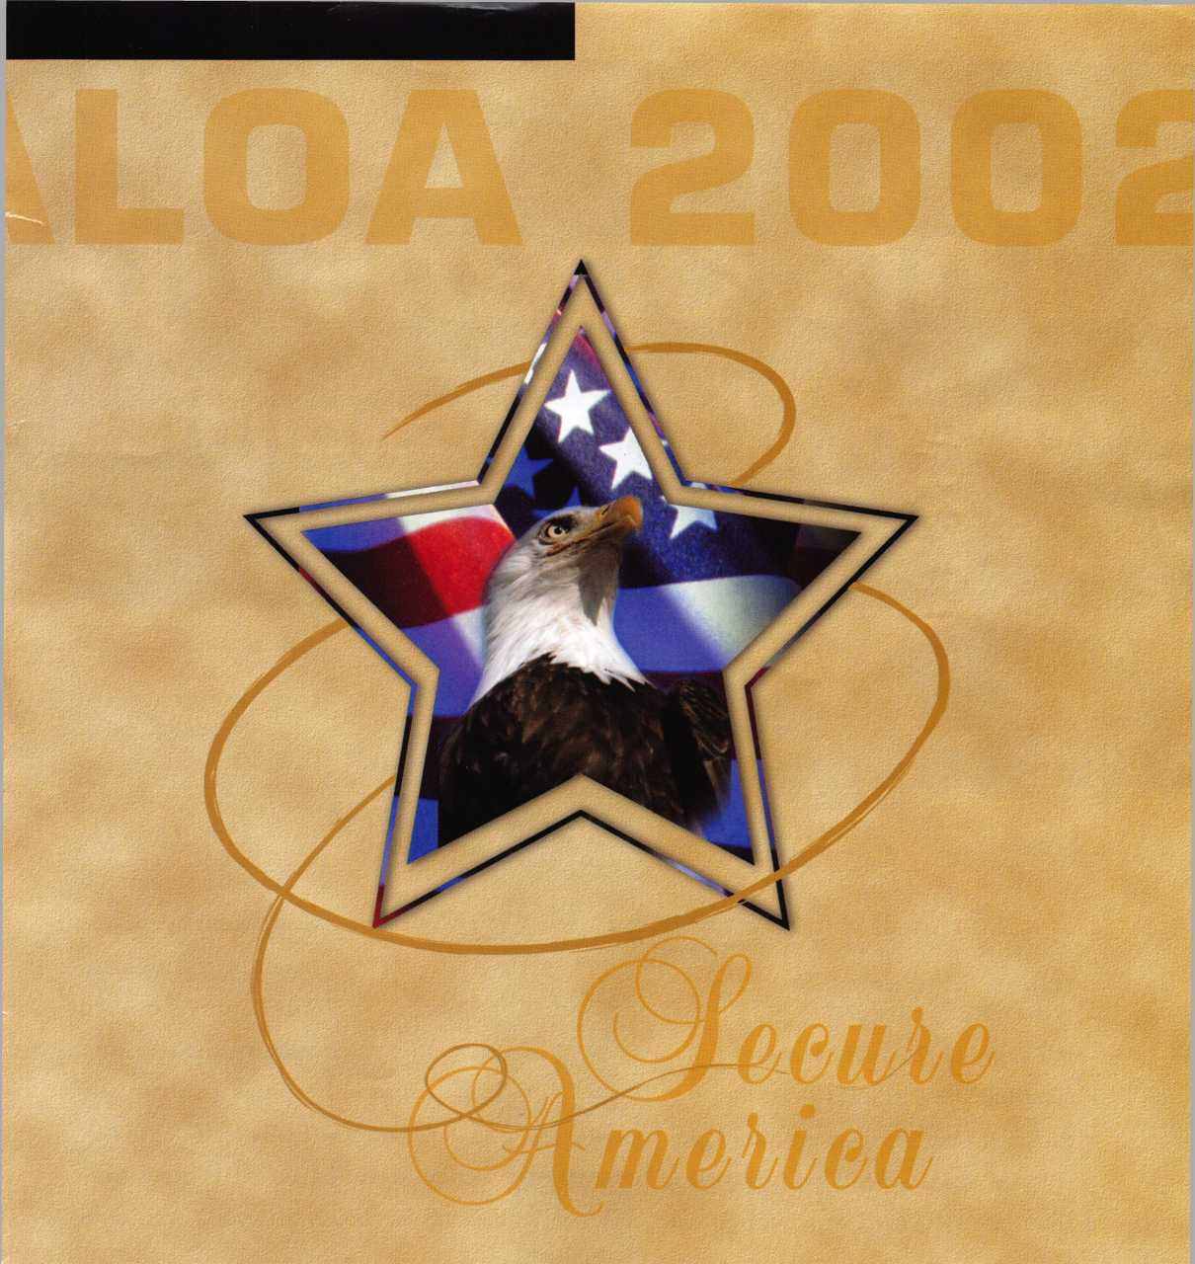

July 22-28, 2002 • Donald E. Stephens Convention Center • Hyatt Regency O'Hare

Es3

Introducing the ePROX™Lock Module (~ only from HID.

Now the security and reliability of proximity access is available in standard electronic locks. It’s battery-powered for stand-alone applications, and, using the same HID card or key fob, it can

eProx™

\ Lock technology available from:

I Alarm Lock

Cypress

Computer

Systems

Ilco Unican

Locknetics

easily augment an  
existing on-line access  
control system.With  
HID battery-powered  
proximity, the one card

solution becomes a simple and  
economical reality. The ePROX™  
Lock Module from HID. Proximity  
access has finally arrived at your door.

[www.hidcorp.com](http://www.hidcorp.com)

Copyright 1999 HID Corporation

We identify with your business. #

**/**

(800) 2 3 7 - P R 0 X (7769) HID CORPORATION

